 

2024

Faculty of Computers and Artificial Intelligence Cairo University

2024 – Second Semester

|  |  |  |
| --- | --- | --- |
| **ID** | **Name** | **Lab** |
| **20210476** | **Yousef Alaa Rabea Mohamed** | **S1, S2** |
| **20210378** | **Marwan Ahmed Abdel-Monem** | **S1, S2** |
| **20210467** | **Yousef Hussien Awad** | **S1, S2** |
| **20211047** | **Salma Ramadan Mohamed** | **S1, S2** |
| **20211025** | **Tayseer Abdelqader mahjoub** | **S1, S2** |

Data Warehouse

DW PROJECT

UNDER SUPERVISION: ENG. AHMED MOHAMED GALAL

Physical model of the source system

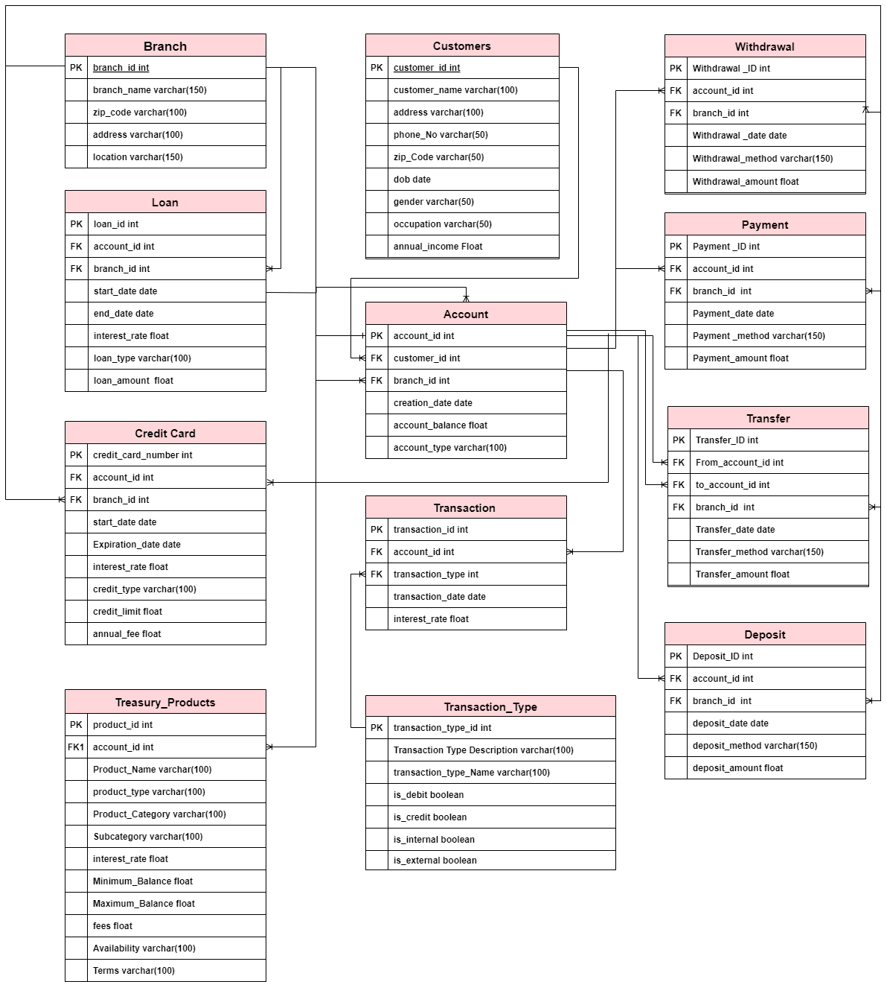

Physical model of your model

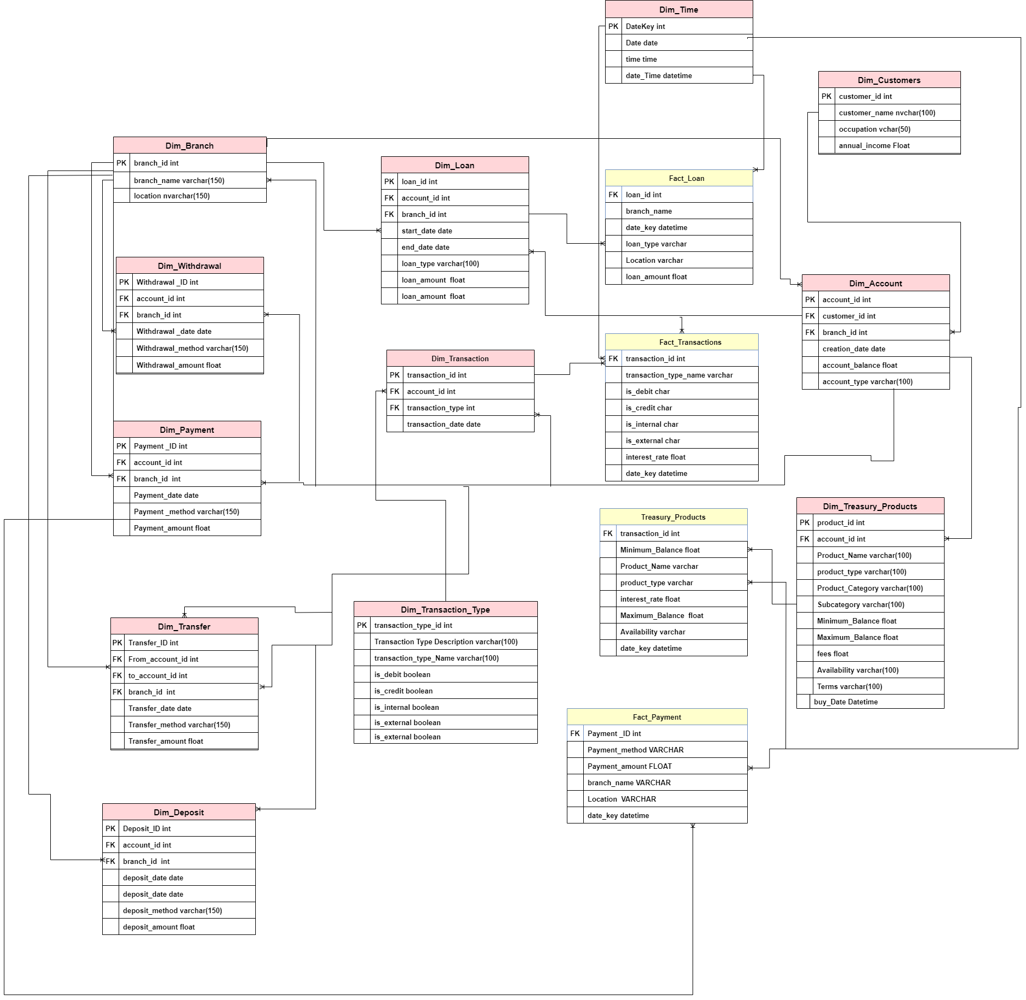

* 1. **Business Process for the model:** Bank Transactions with customer accounts and his treasury Products

**3.b.c.**

|  |  |  |
| --- | --- | --- |
| **Fact Table Name** | **Representation** | **Measures** |
| **Fact_Loan**  **(Transaction)** | Shows data about loans made by the bank. It includes data about loan amounts, types, interest rates,  terms, and other loan-specific attributes with each Branch. | * **loan_amount (Full)** |
| * **Every record shows the loan made to the account in a particular date format from the bank branch.** |
| **Fact_Transactions**  **(Transaction)** | Shows data about different types of transactions that occur within the bank, including deposits, withdrawals, transfers, and payments. It includes data about the transaction amount, date, time, location,  and other transaction-specific attributes. | * **interest_rate (Semi)** |
| * **Every record shows the transaction that the account performed in a particular date format.** |
| **Treasury_Products**  **(Transaction)** | Shows data about the different products and services offered bythe bank, such as mortgages, investments, insurance policies, etc. It includes data about the product type, pricing, terms,  and other product-specific attributes. | * **interest_rate (Semi)** * **Fees (Full)** |
| * **Every record shows the product-specific sales transaction in a particular date format.** |
| **Fact_Payment**  **(Transaction)** | Shows data about payments that customers have made or received from the bank. It includes data about the payment’s amount, date,time, place, and other payment-specific attributes. It also includes data about the accounts and customers that performed each payment transaction. | * .**Payment_amount (Full)** |
| * **Every record shows the payment transaction made by the account in a particular date format.** |

**3.d Dimensions Representation**

|  |  |
| --- | --- |
| **Dimension Table Name** | **Representation** |
| **Dim_Time**  **conformed** | This dimension is used to track various time-related information, such as date, day, month, quarter, year, etc. It can be used to filter and analyze data based on different time periods. |
| **Dim_Treasury_Products**  **Slowly(Type1)** | This dimension is used to track information related to different treasury products offered by the bank, such as savings accounts,  money market accounts, certificates of deposit, etc. It can be used to |

|  |  |  |
| --- | --- | --- |
|  | analyze and compare different products based on their interest rates, fees, minimum balance requirements, etc. | |
| **Dim_Branch**  **Slowly(Type1) &**  **Conformed** | This dimension is used to track information related to the various branches of the bank, such as branch location, address, phone  number, etc. It can be used to filter and analyze data based on different branches. | |
| **Dim_Loan**  **Slowly(Type1)** | This dimension is used to track information related to loans offered by the bank, such as loan type, interest rate, loan amount, start date, end date, etc. It can be used to analyze and compare different loans  based on their terms and performance. | |
| **Dim_Customers**  **Slowly(Type1)** | This dimension is used to track information related to bank customers, such as customer name, address, phone number, occupation, annual income, etc. It can be used to analyze and  segment customers based on their demographics and behaviors. | |
| **Dim_Account**  **Slowly(Type1)&**  **conformed** | This dimension is used to track information related to bank accounts, such as account type, account balance, creation date, etc. It can be  used to analyze and compare different accounts based on their performance. | |
| **Dim_Transaction**  **Slowly(Type1)** | This dimension is used to track information related to different transactions, such as transaction date, transaction type, transaction amount, etc. It can be used to filter and analyze data based on  different types of transactions. | |
| **Dim_Transaction_Type**  **Slowly(Type1)** | This dimension is used to track information related to different transaction types, such as deposit, withdrawal, transfer, payment, etc. It can be used to filter and analyze data based on different types of  transactions. | |
| **Dim_Deposit**  **Slowly(Type1)** | This dimension is used to track information related to deposits made by customers, such as deposit amount, deposit date, deposit method, etc. It can be used to analyze and compare different deposits based  on their amounts and sources. | |
| **Dim_Transfer**  **Slowly(Type1)** | This dimension is used to track information related to transfers made between accounts, such as transfer amount, transfer date, transfer method, etc. It can be used to analyze and compare different  transfers based on their amounts and sources. | |
| **Dim_Payment**  **Slowly(Type1)** | This dimension is used to track information related to payments made by customers, such as payment amount, payment date, payment method, etc. It can be used to analyze and compare  different payments based on their amounts and sources. | |
| **Dim_Withdrawal**  **Slowly(Type1)** | This dimension is used to track information related to withdrawals made by customers, such as withdrawal amount, withdrawal date, withdrawal method, etc. It can be used to analyze and compare different withdrawals based on their amounts and sources. |  |

**Package To Load STG and DWH**

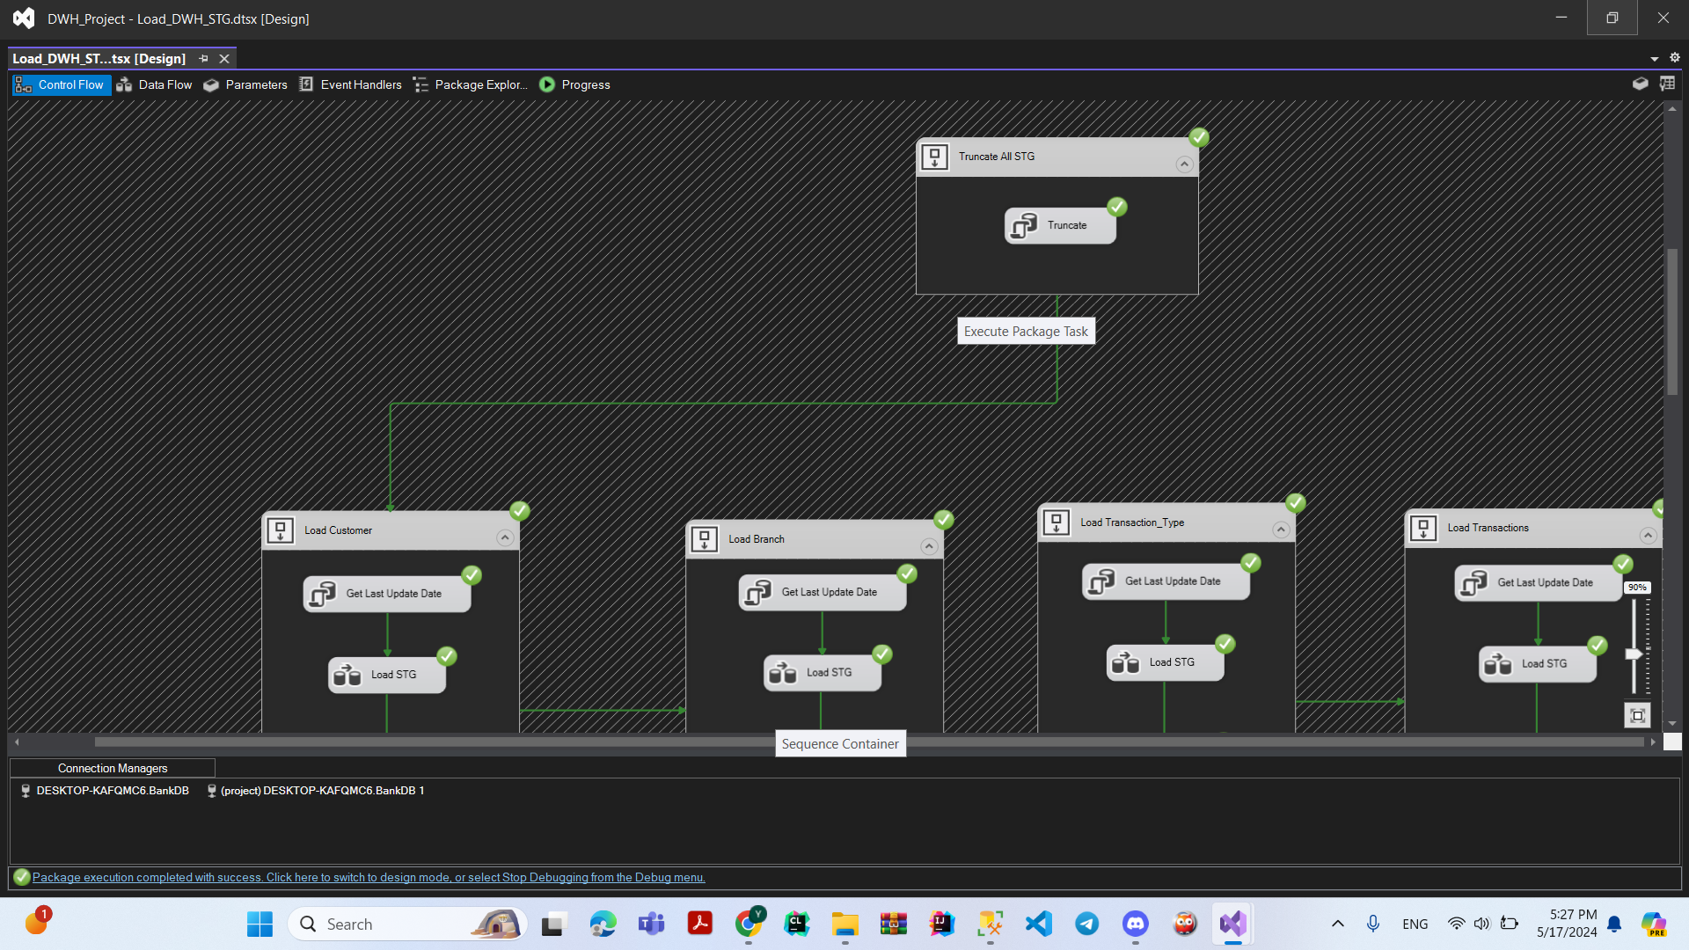

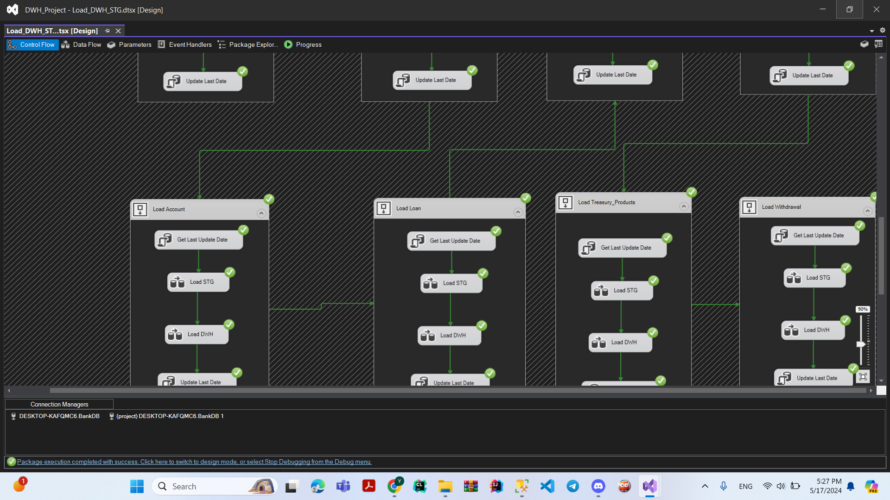

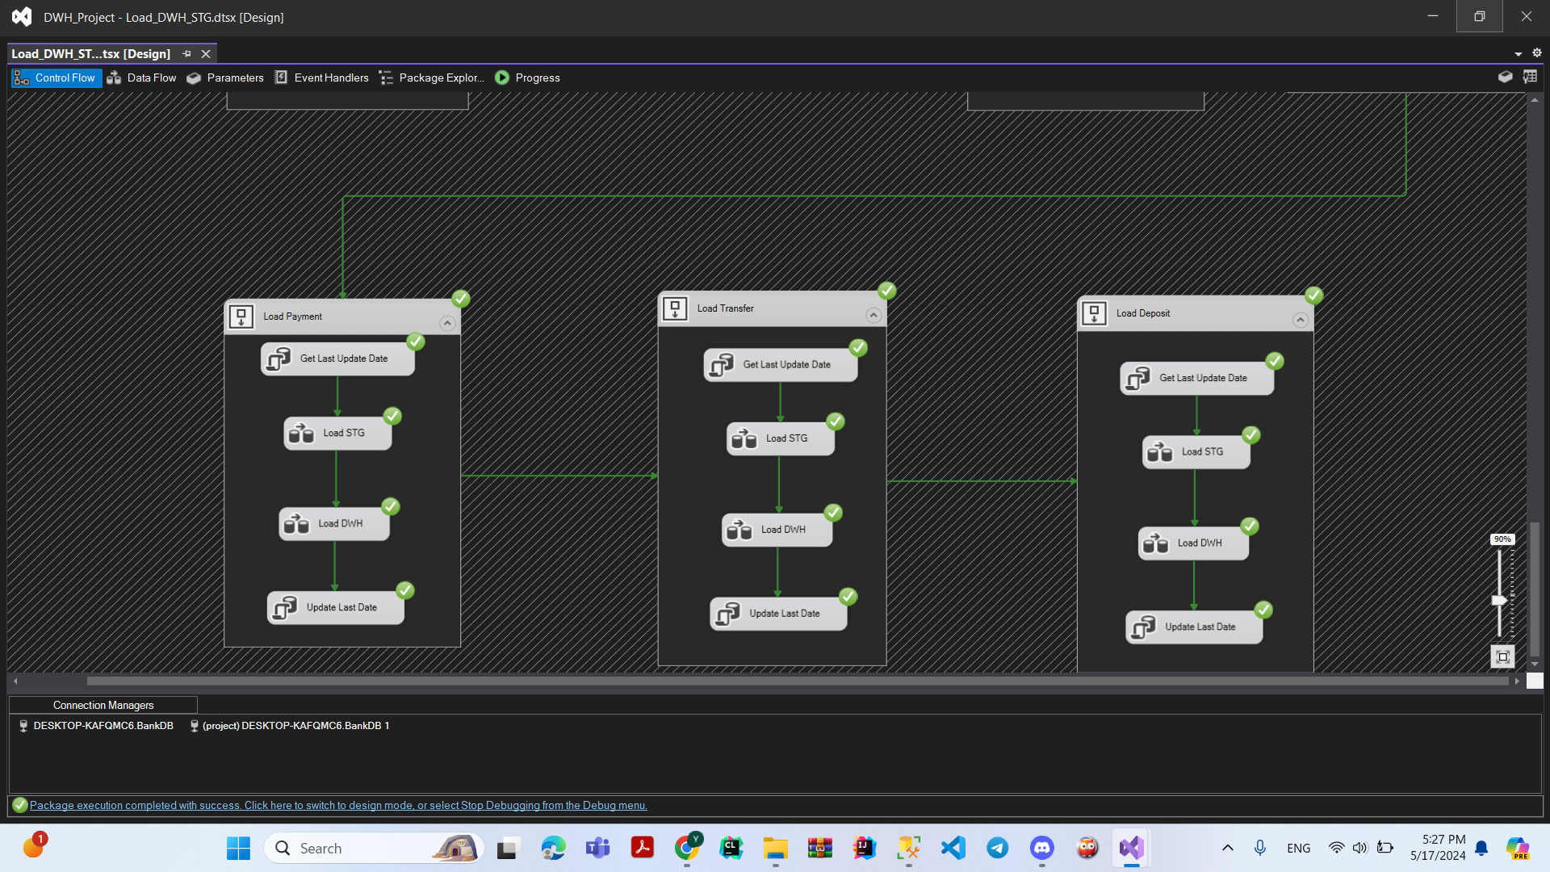

**EX: For STG Load**

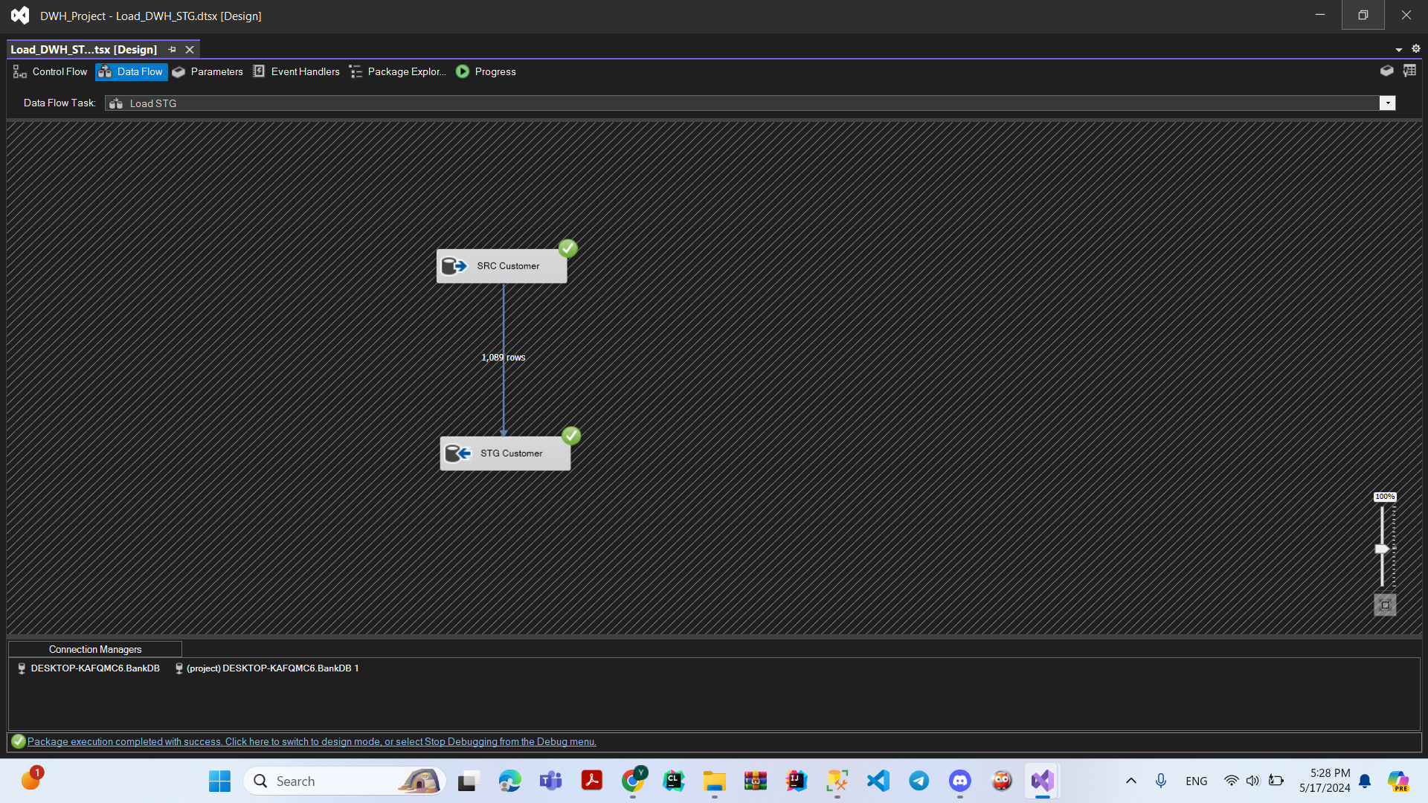

**Ex: For Load DWH**

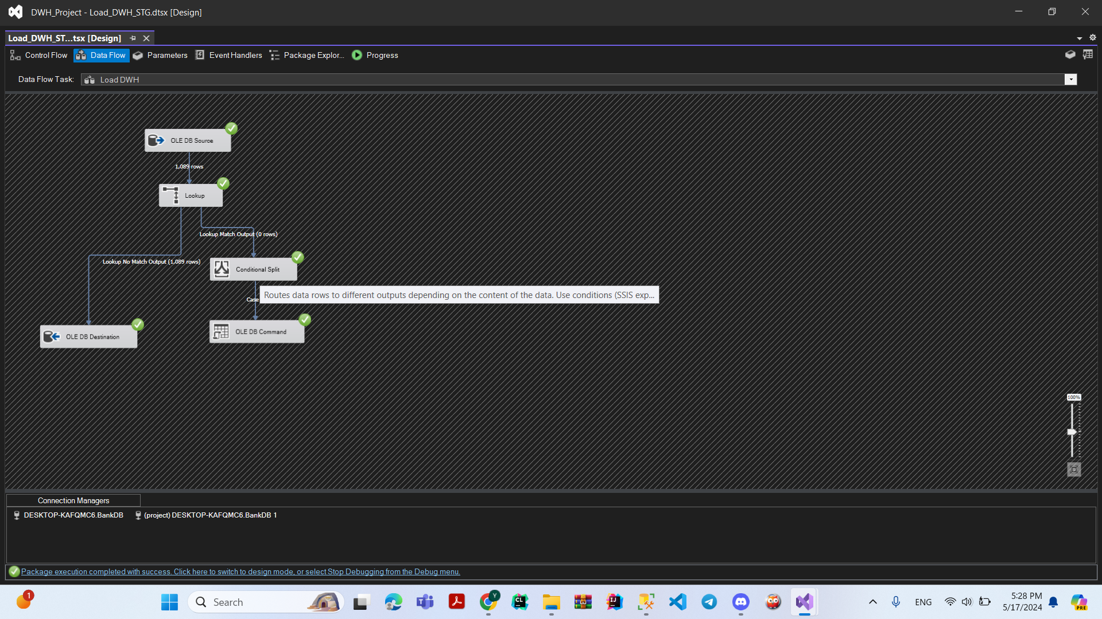

**Incremental Load**

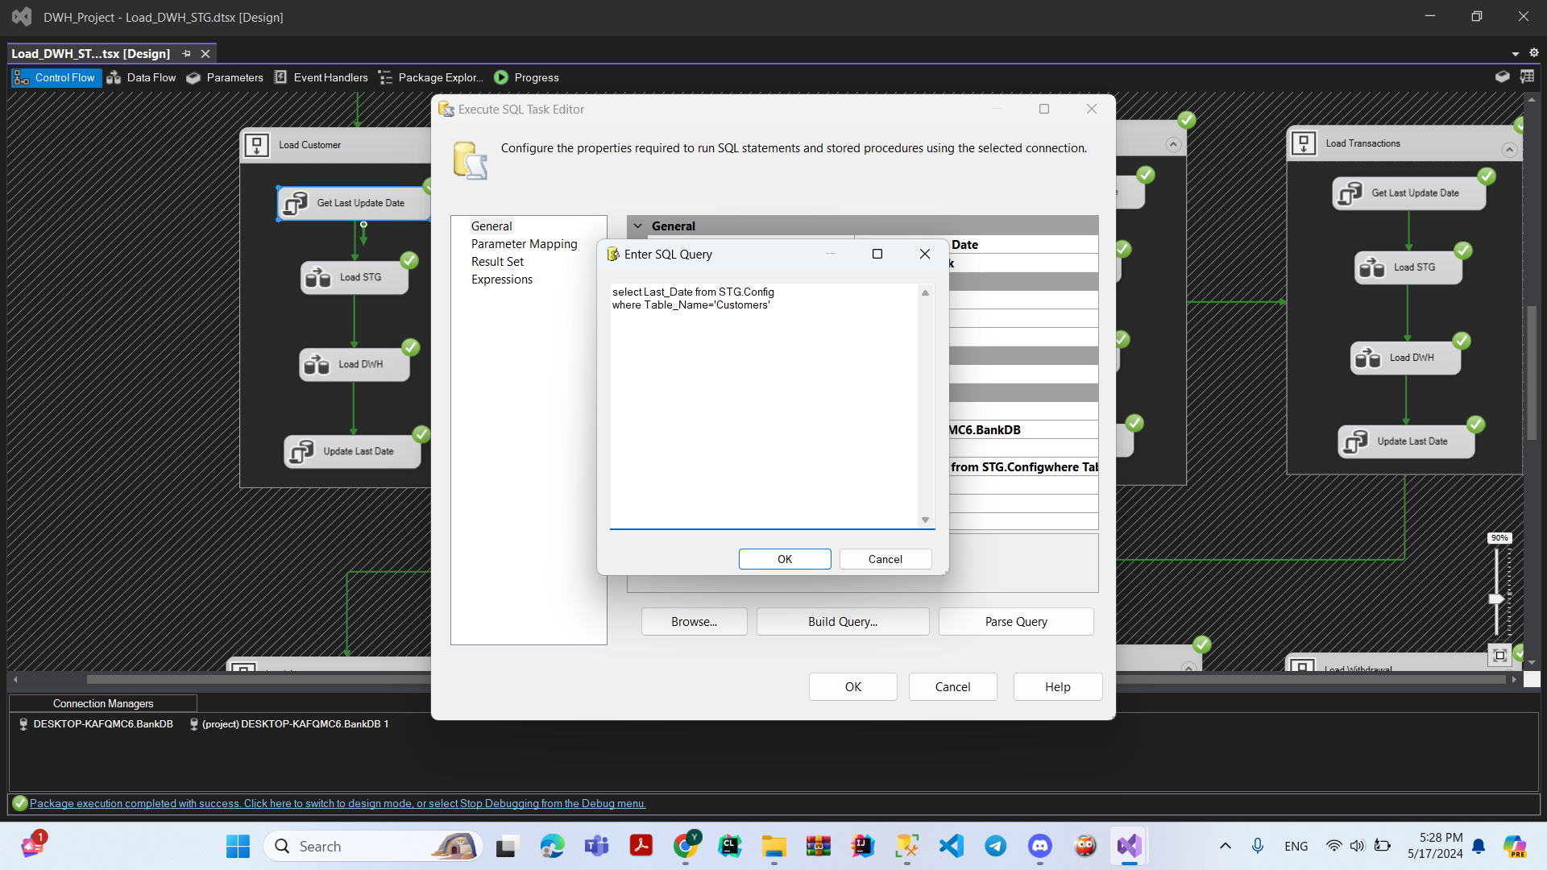

**Update Date After Load**

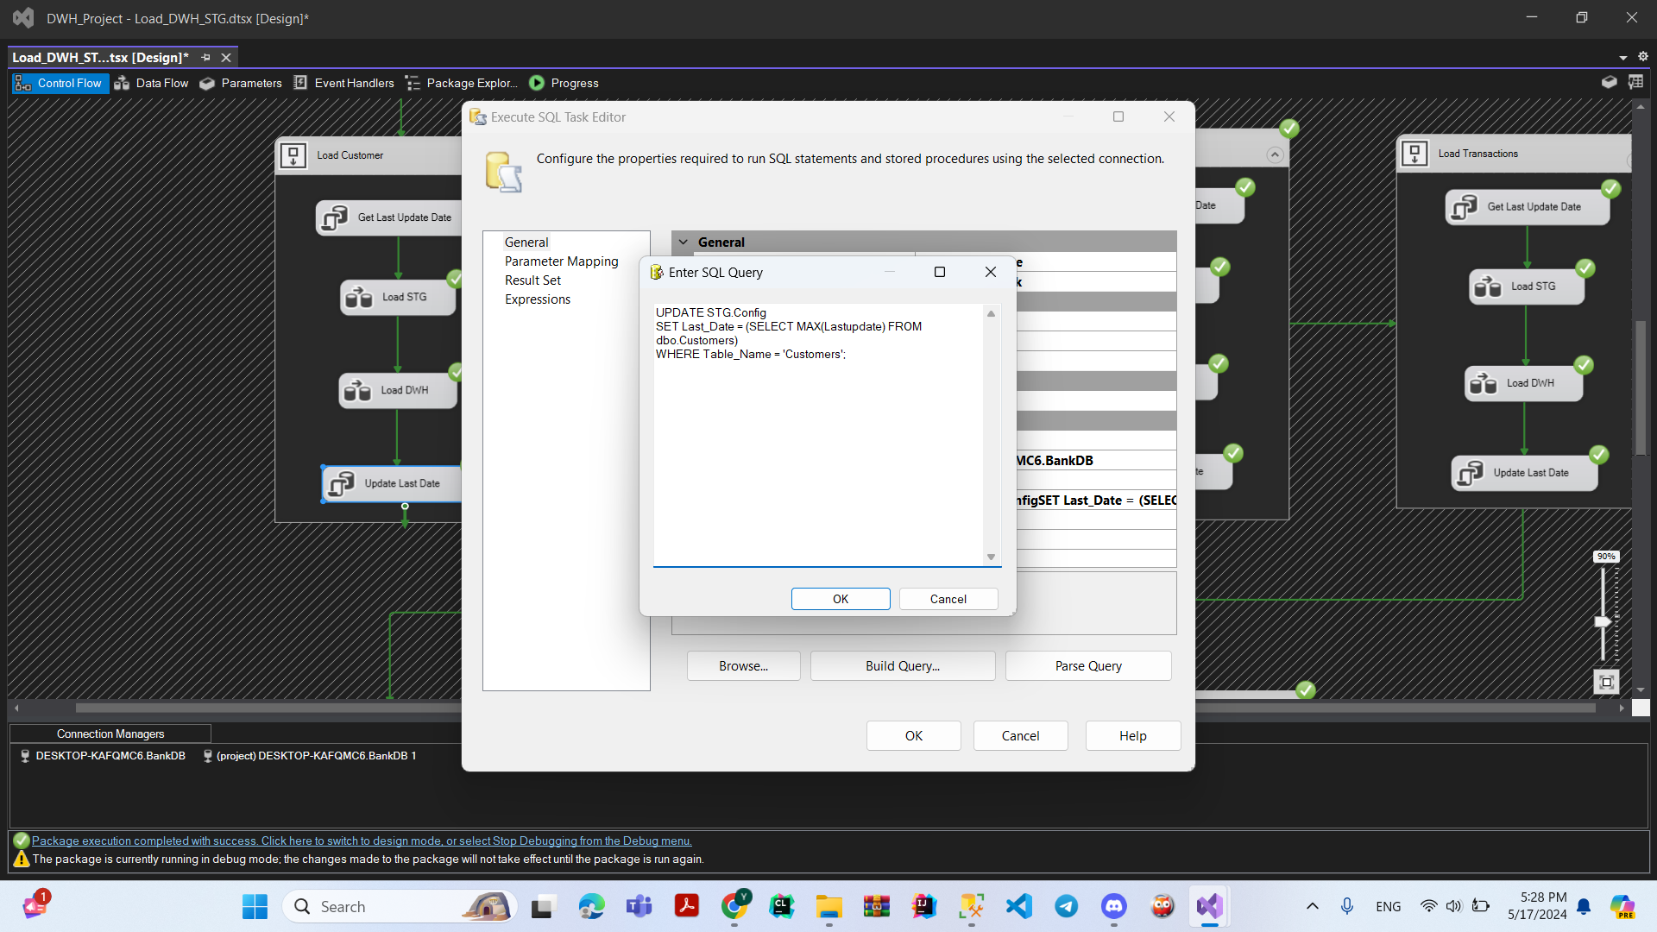

**Package Call Package to Run Load DWH &STG then Load Facts**

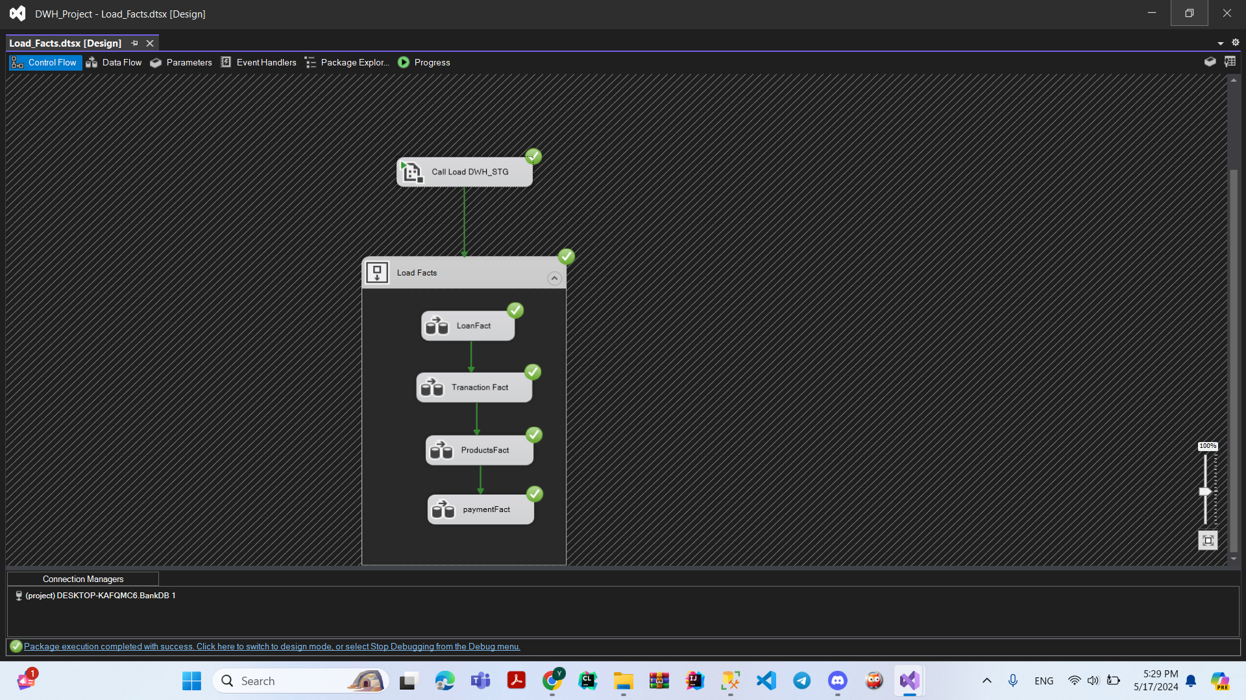

**EX :For Load Fact Table**

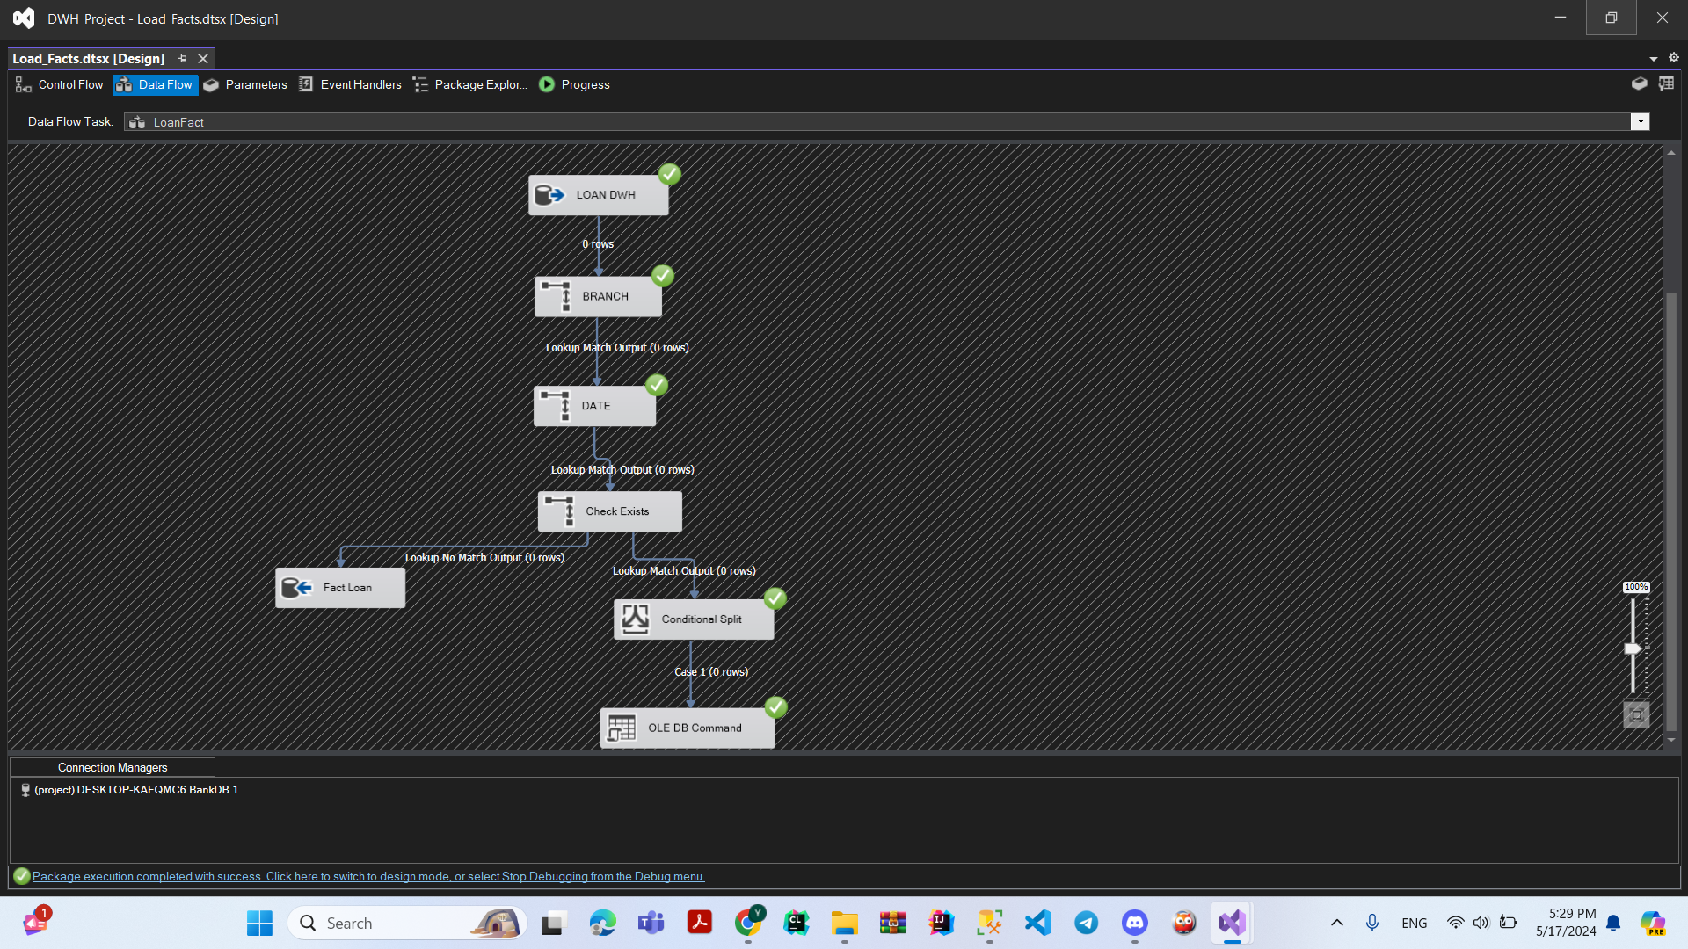

**This Link To Watch Complete Project Photos**

**[Press ME](https://drive.google.com/file/d/1CppsiRwuh9zrtgZsNFFT20ZFRWG0t77p/view?usp=sharing)**

**Queries Screenshot For Load Fact**

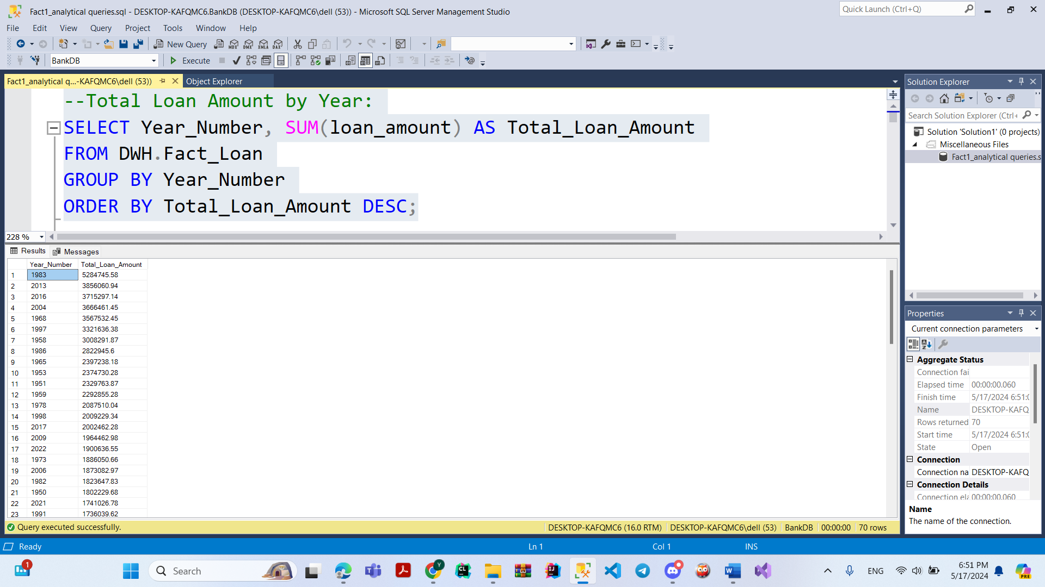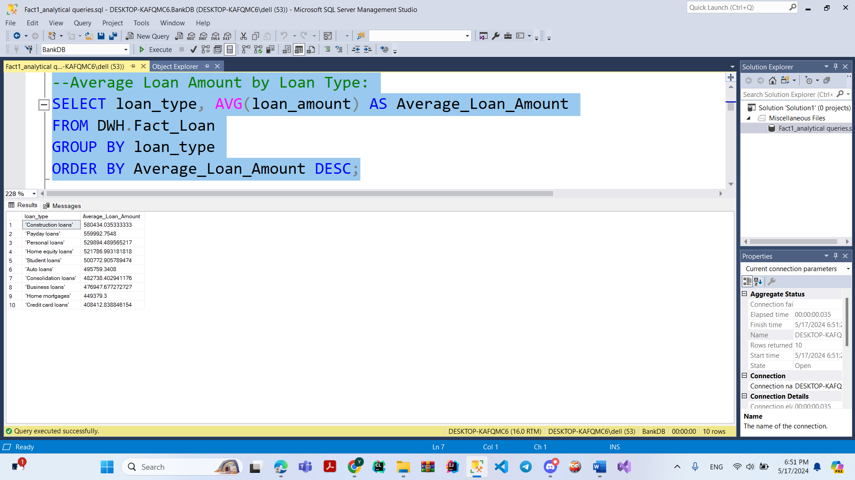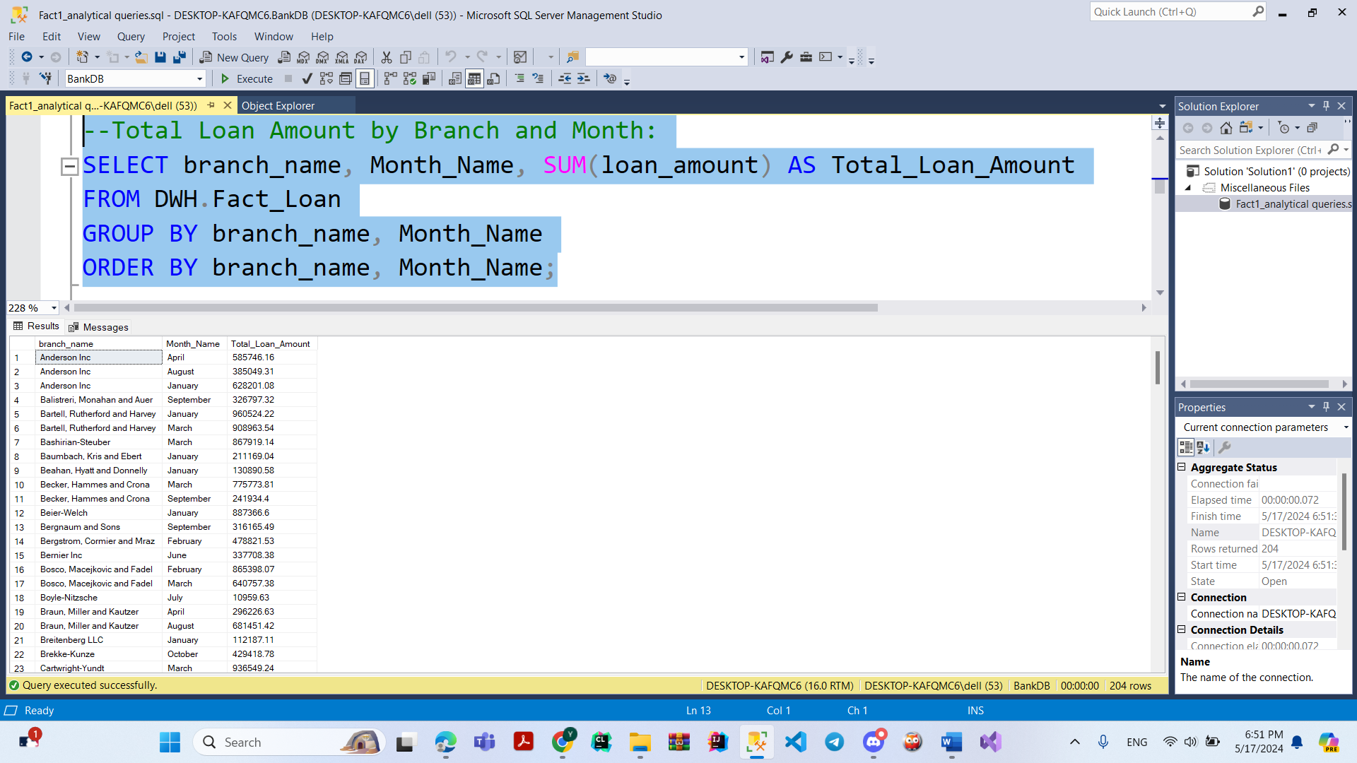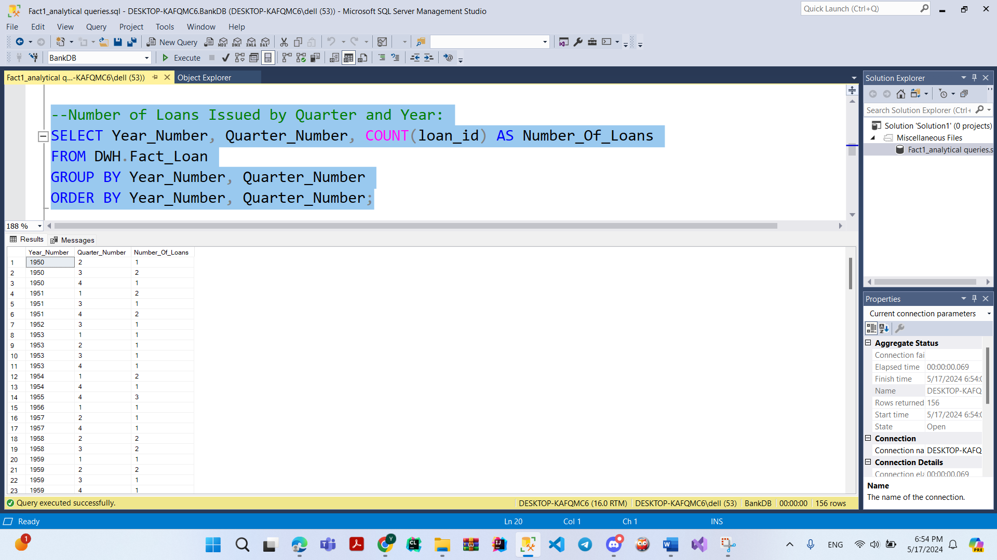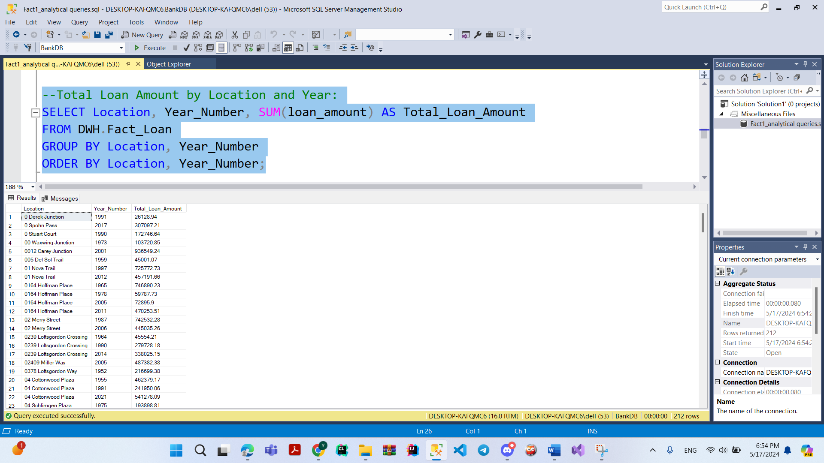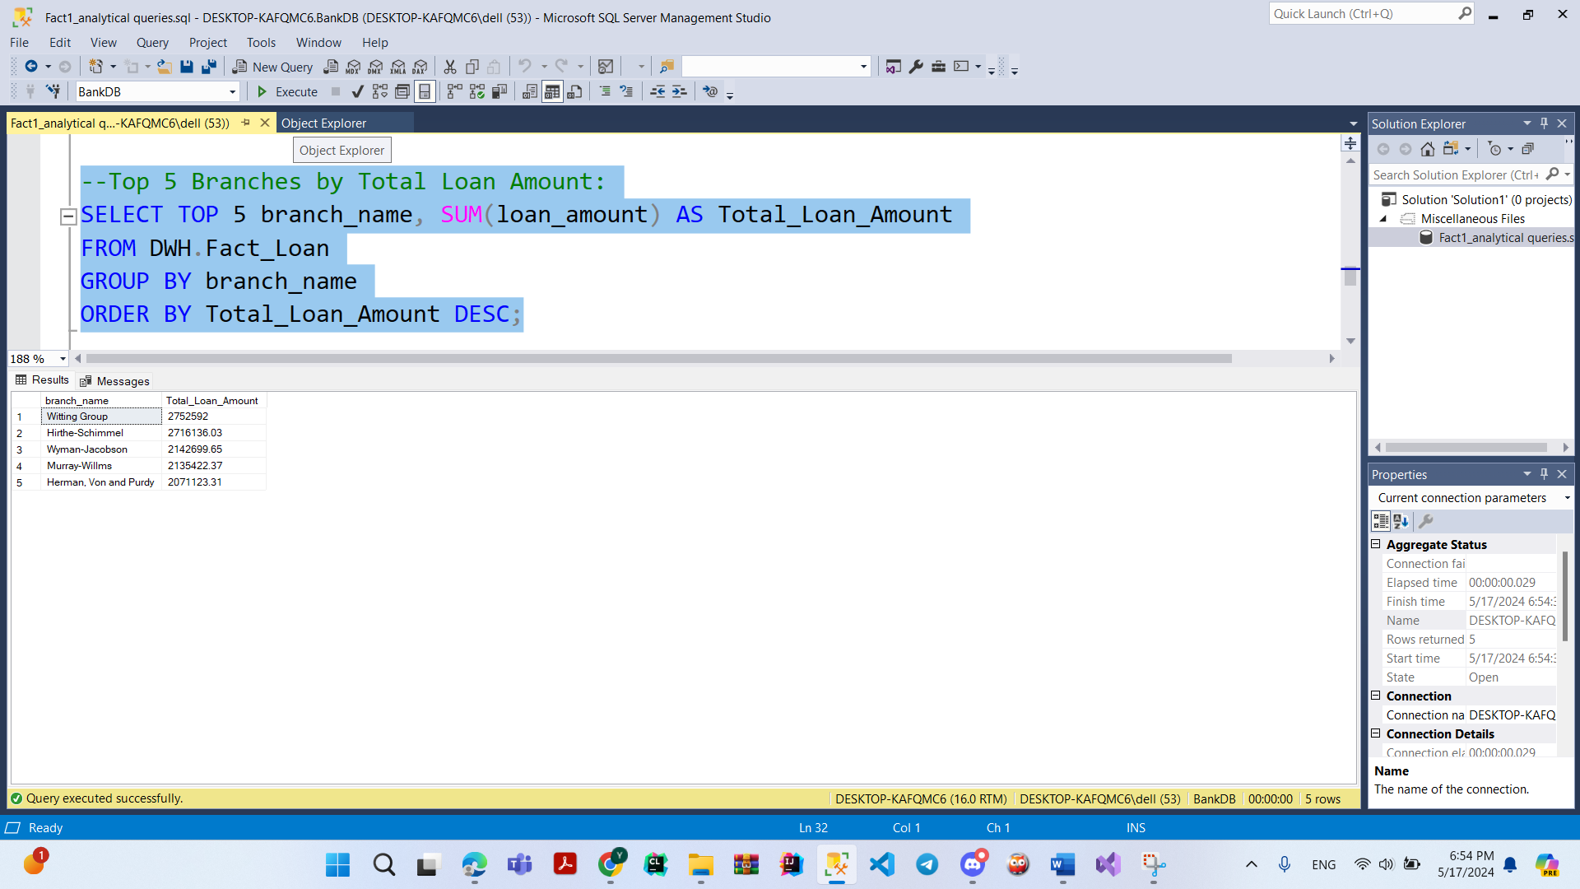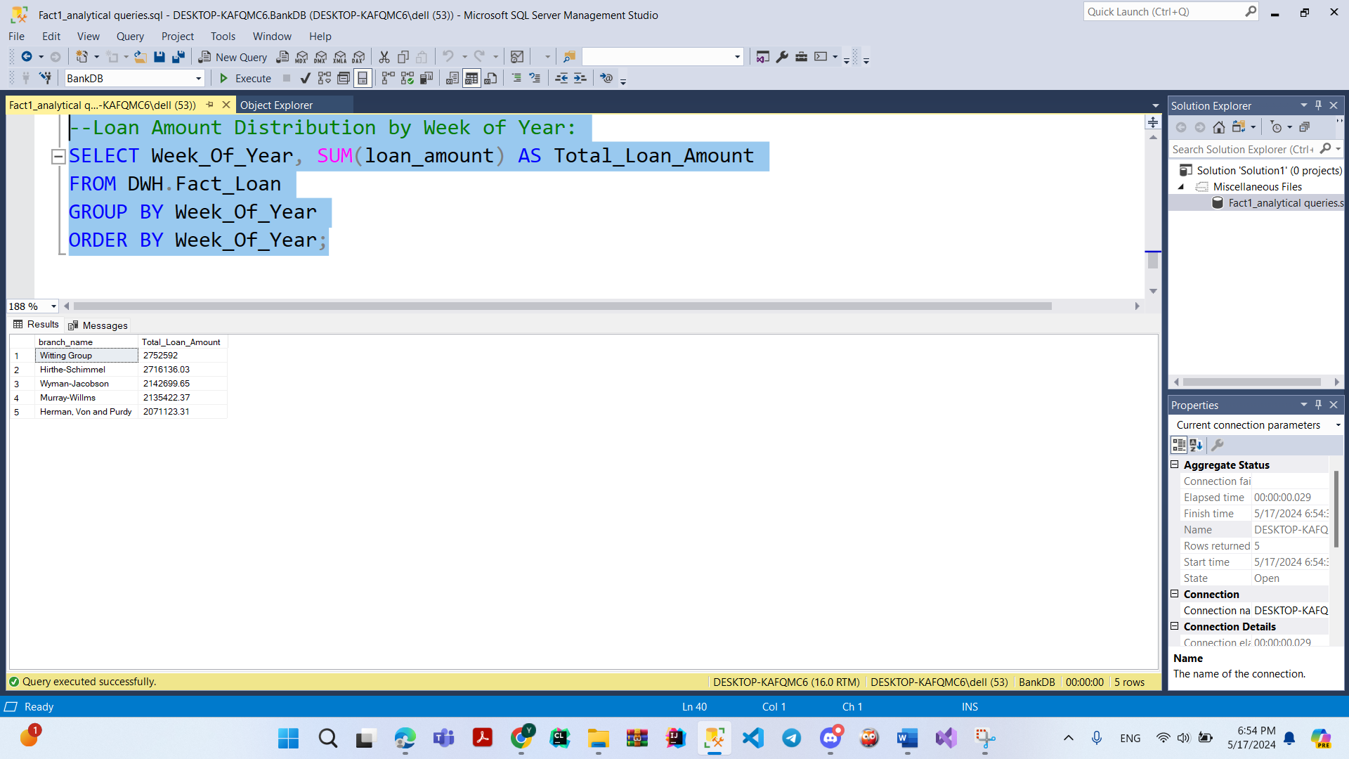

**Queries Screenshot For Transaction Fact**

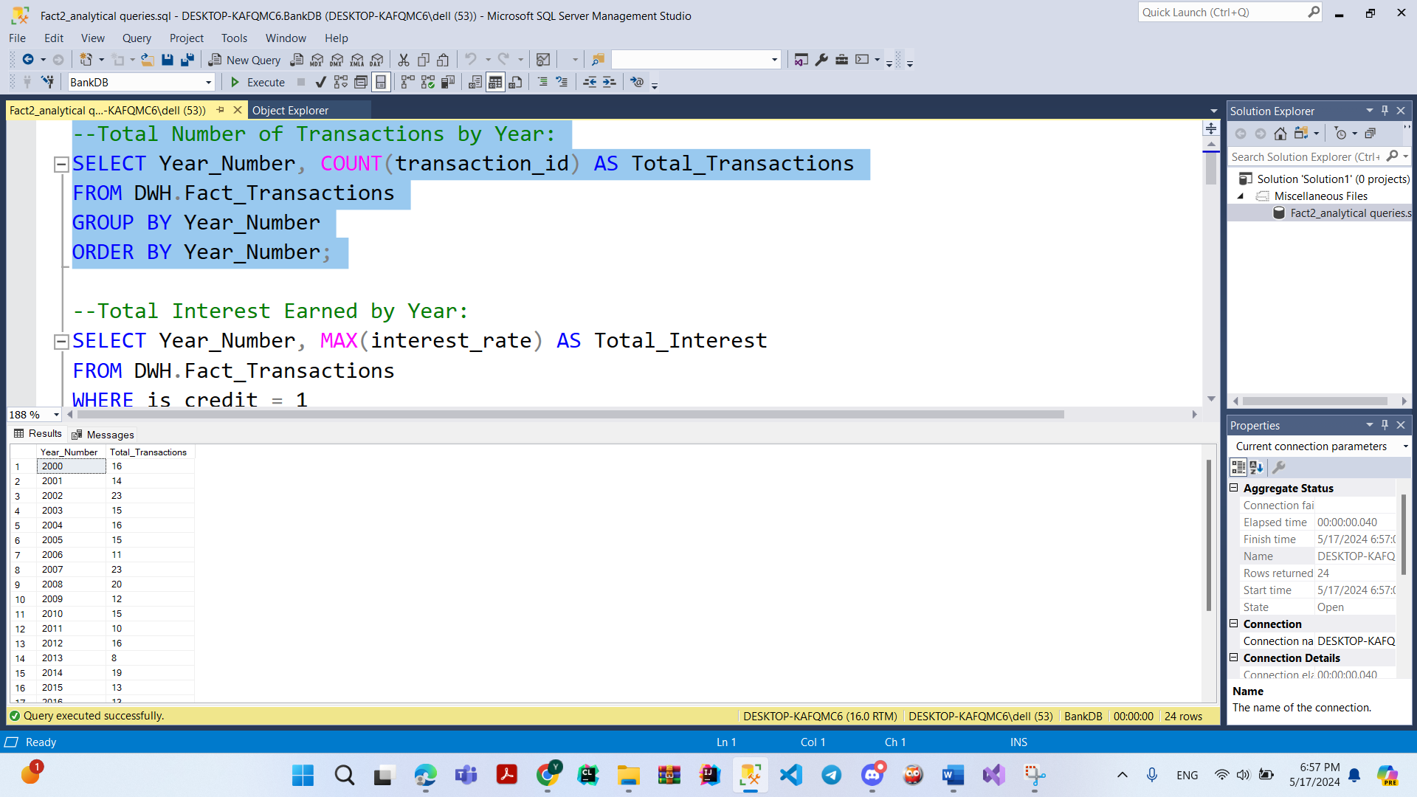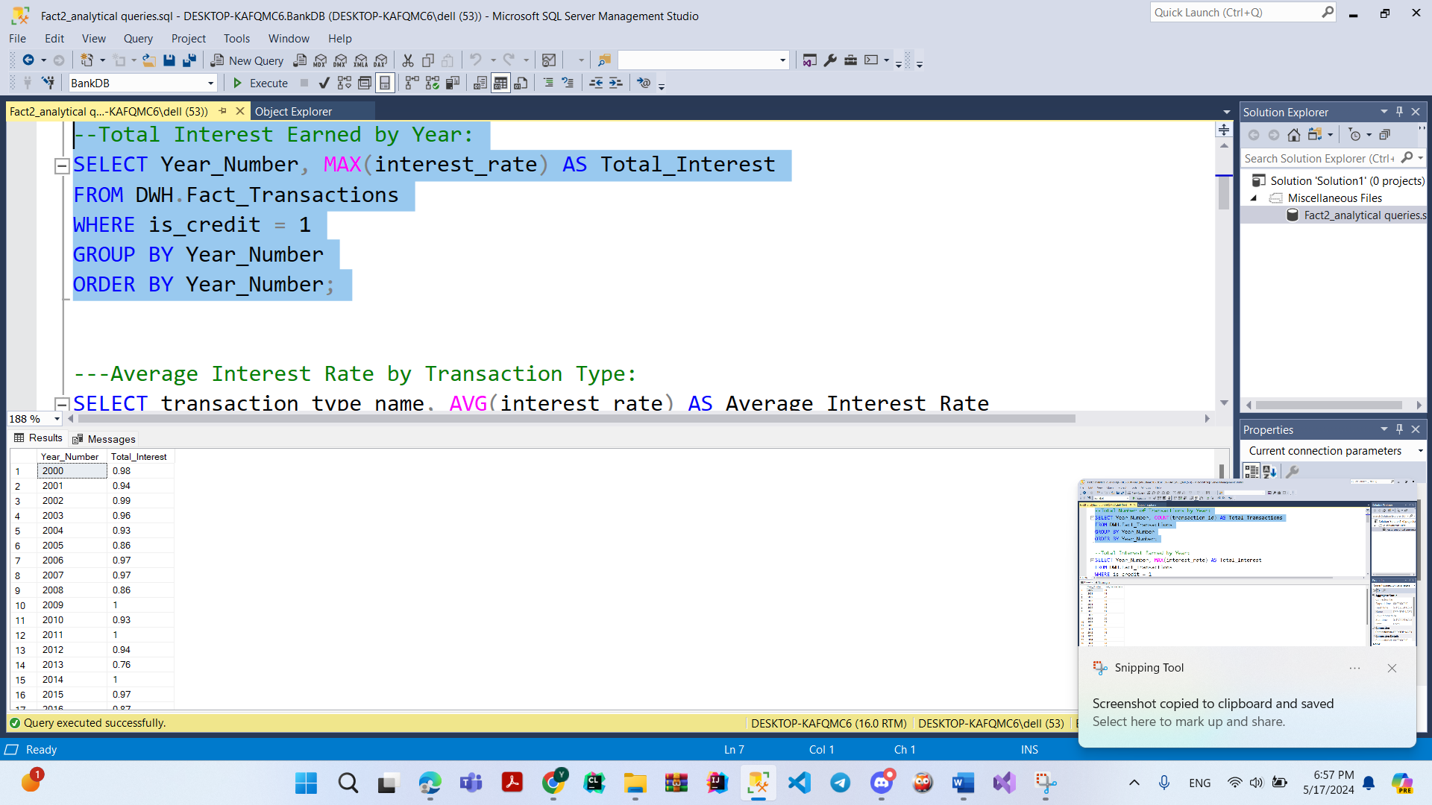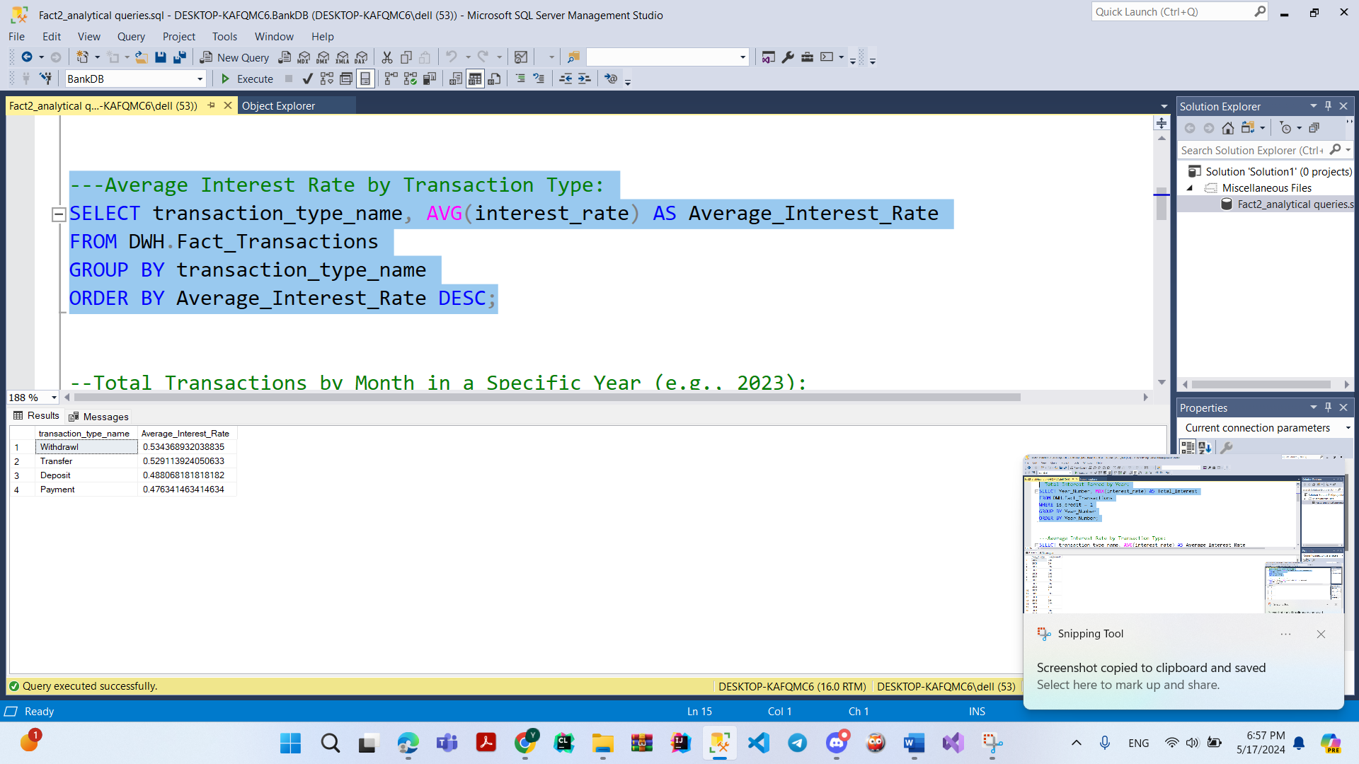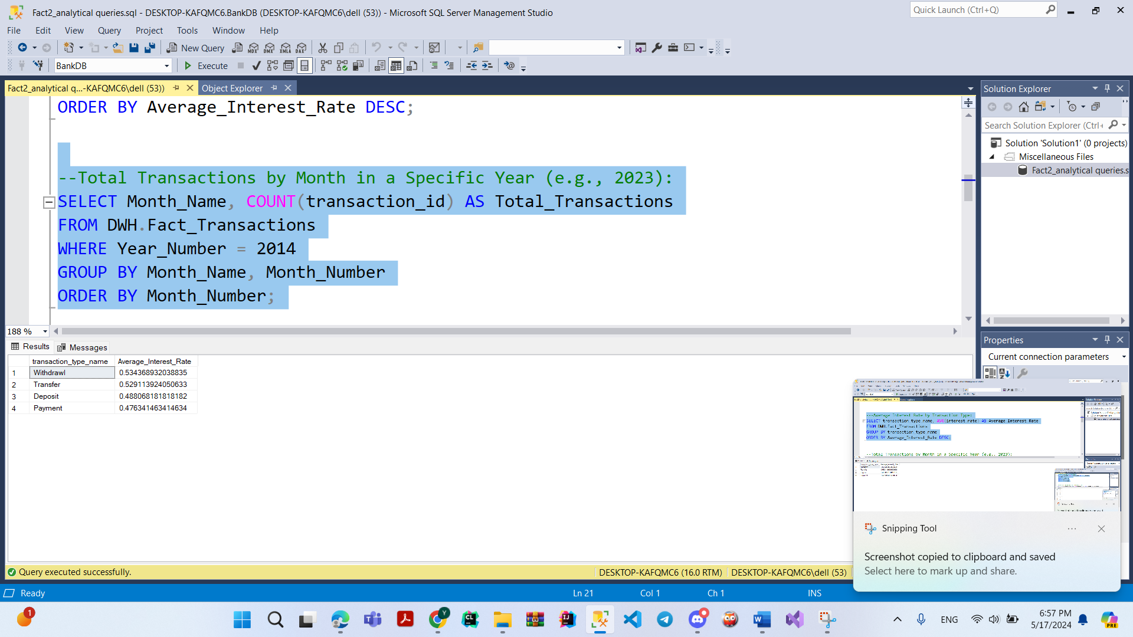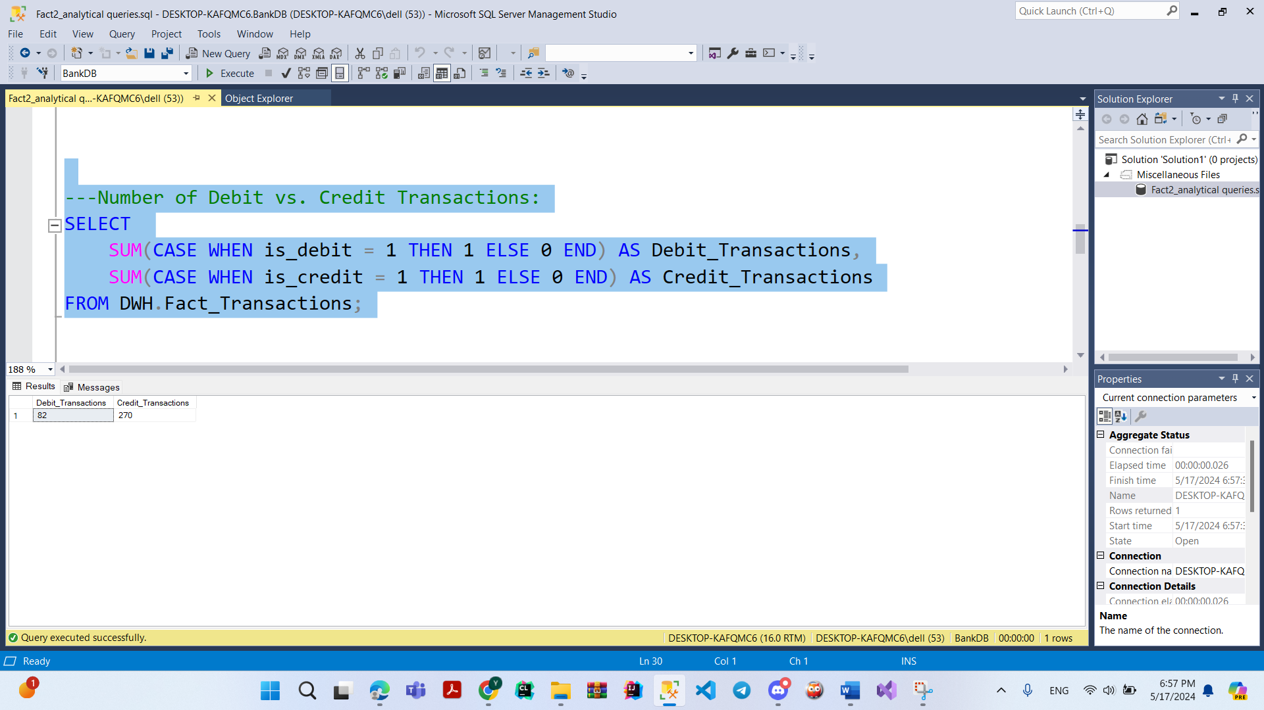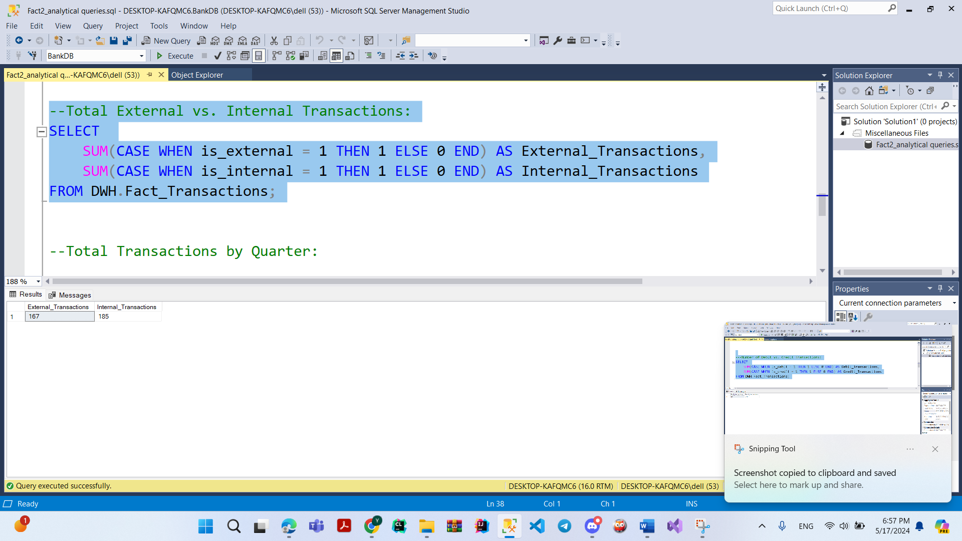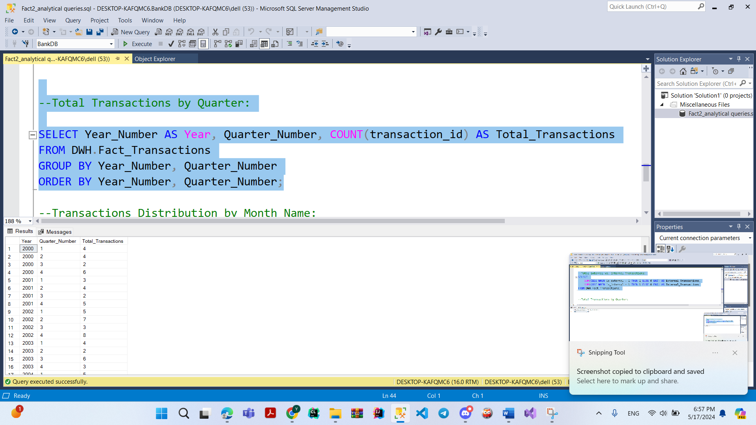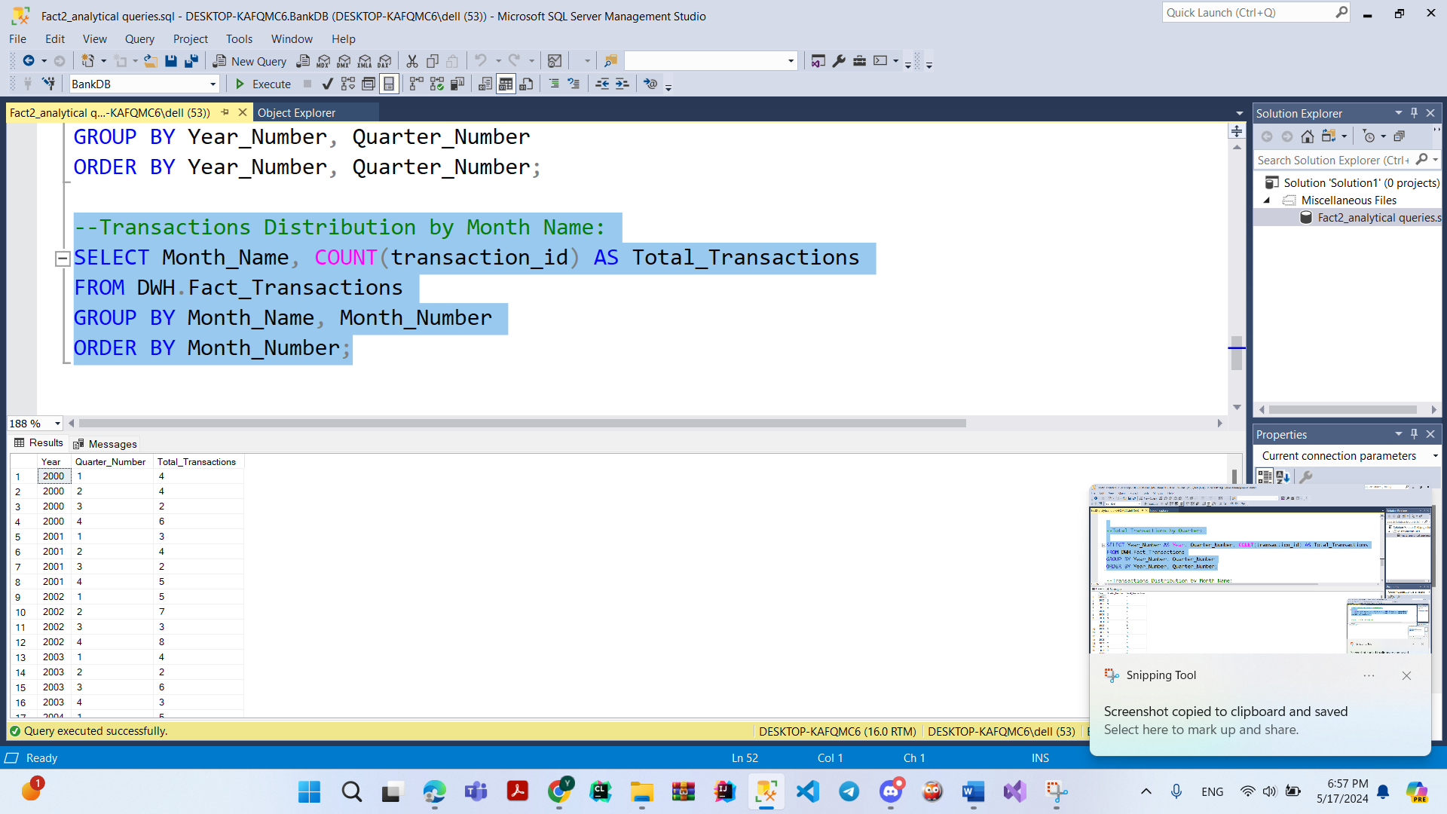

**Queries Screenshot For Products Fact**

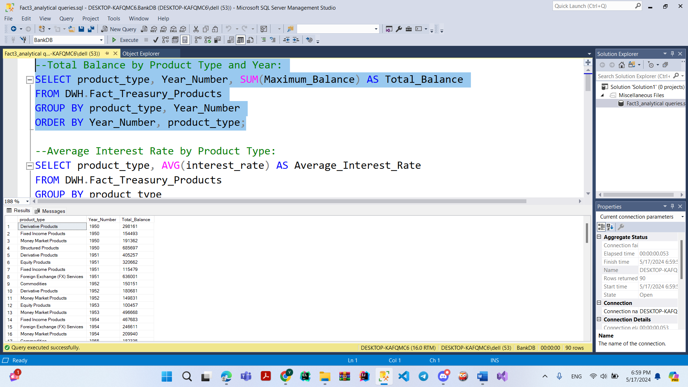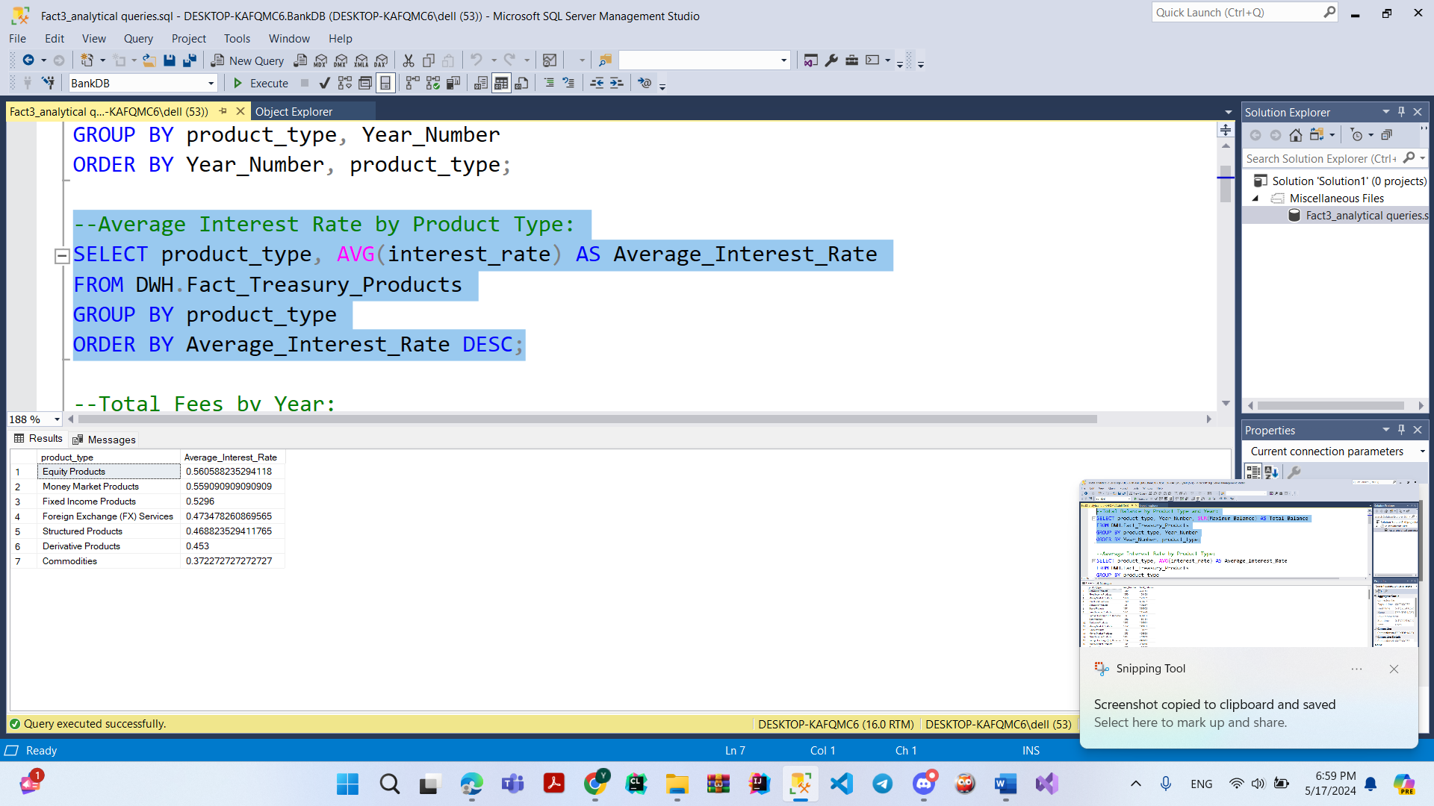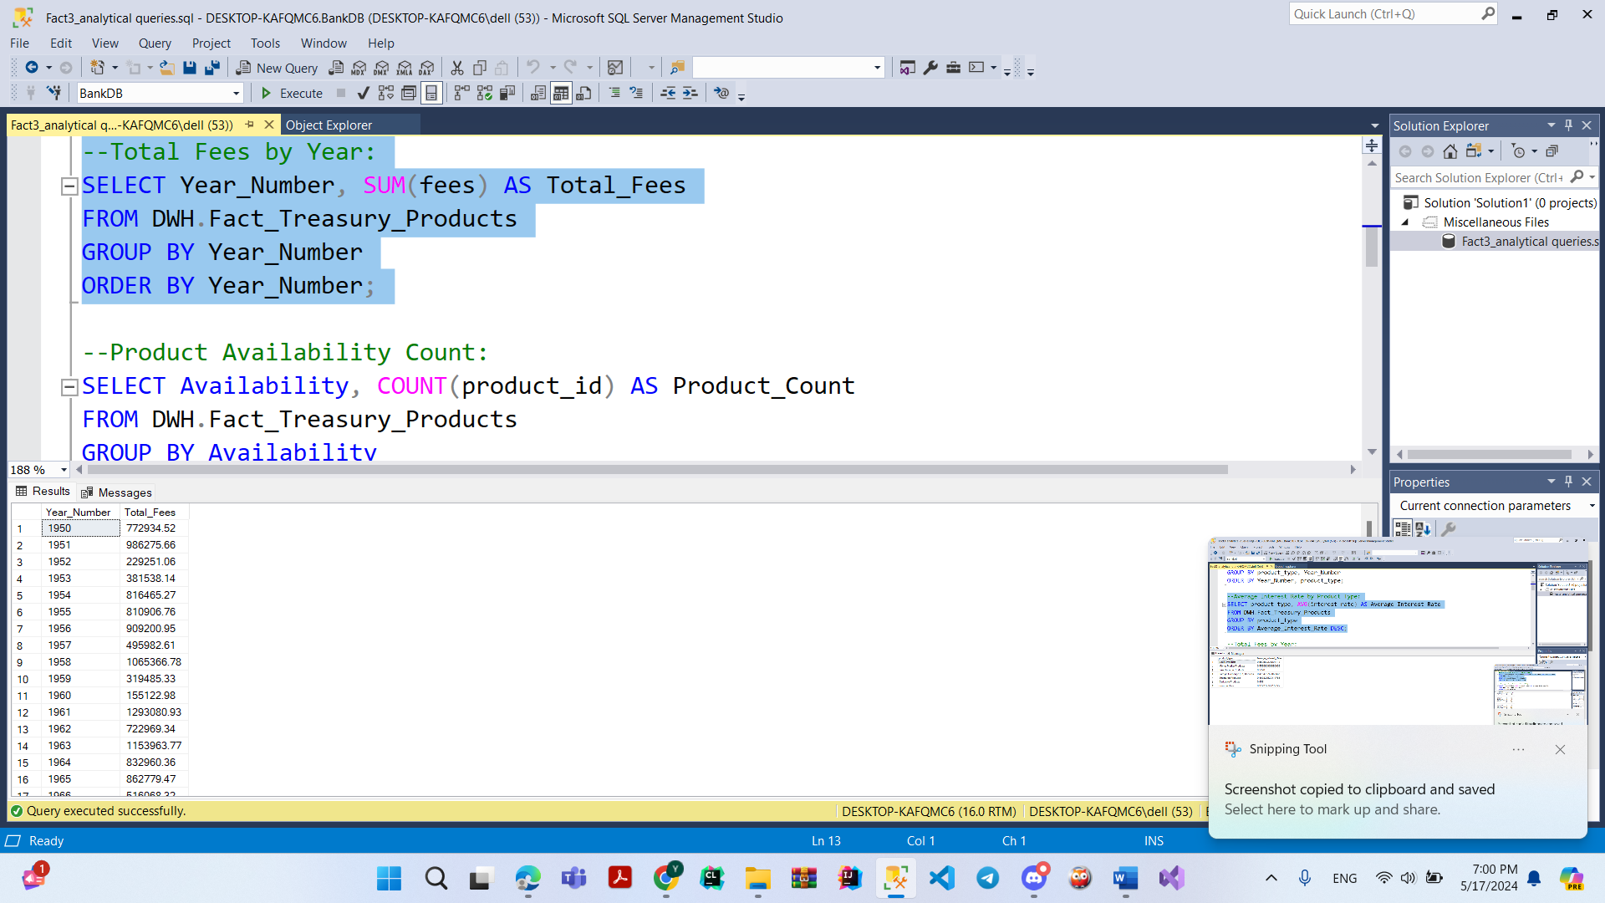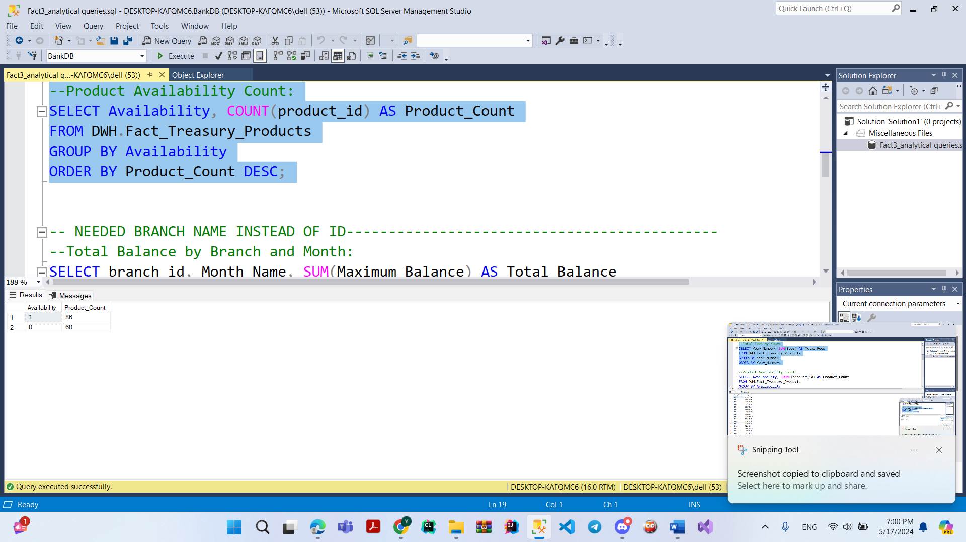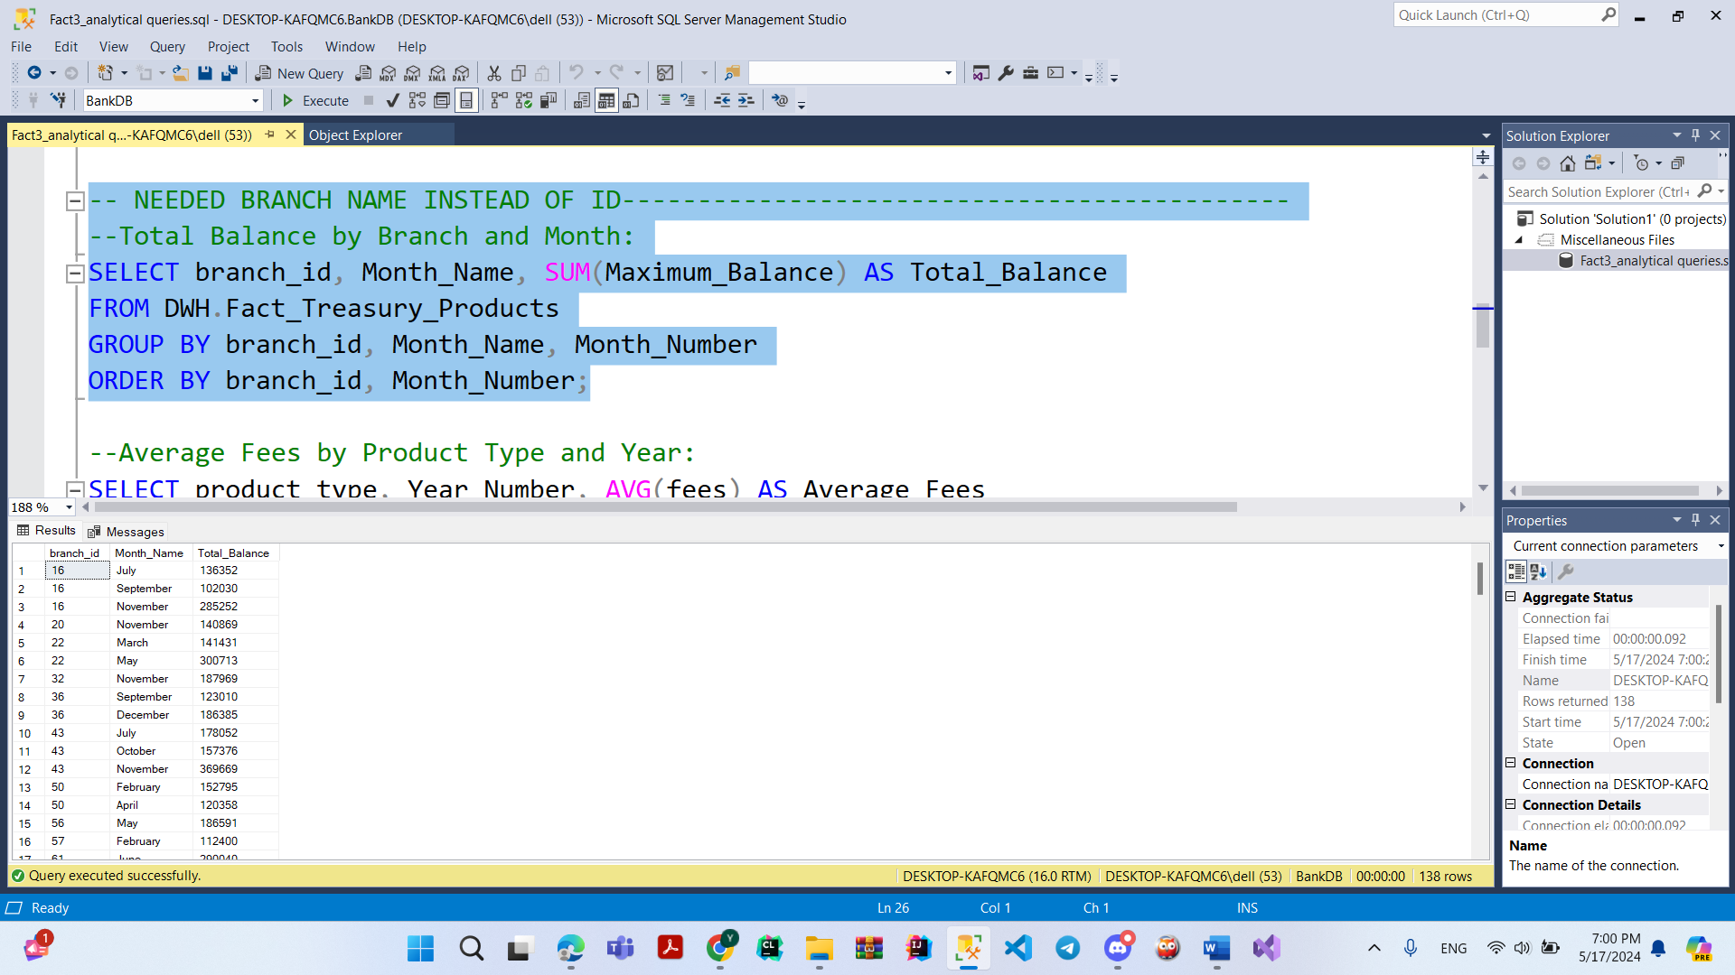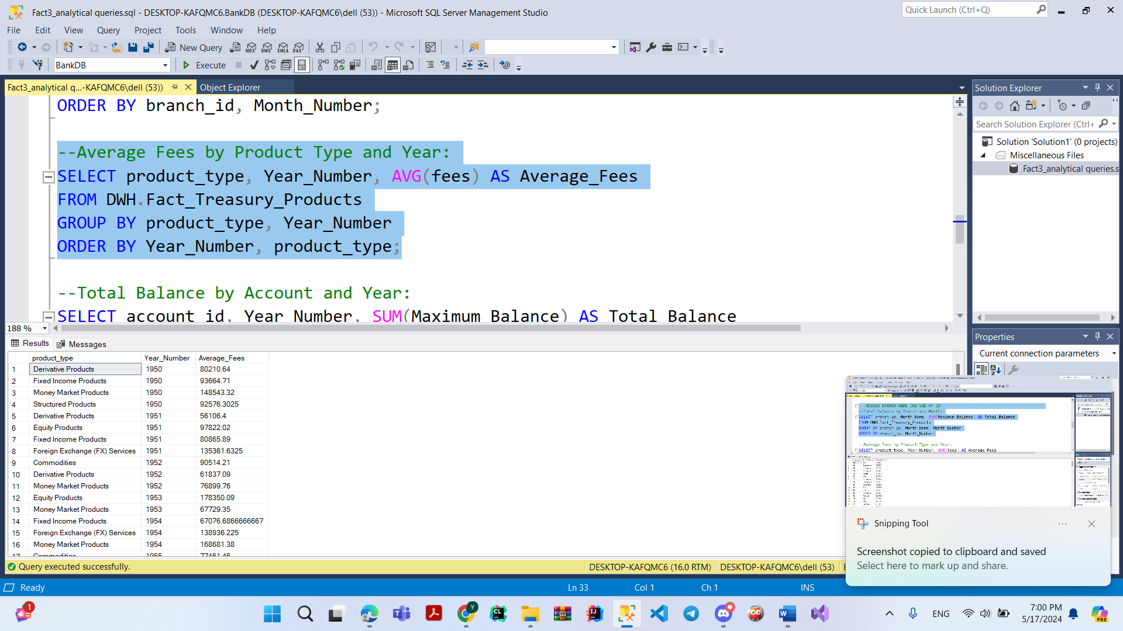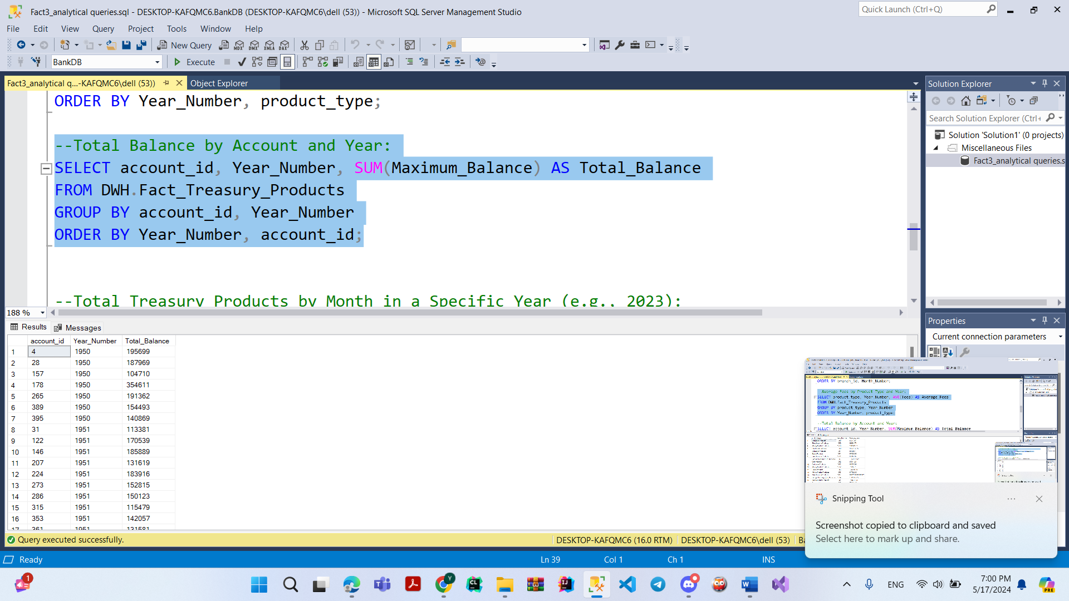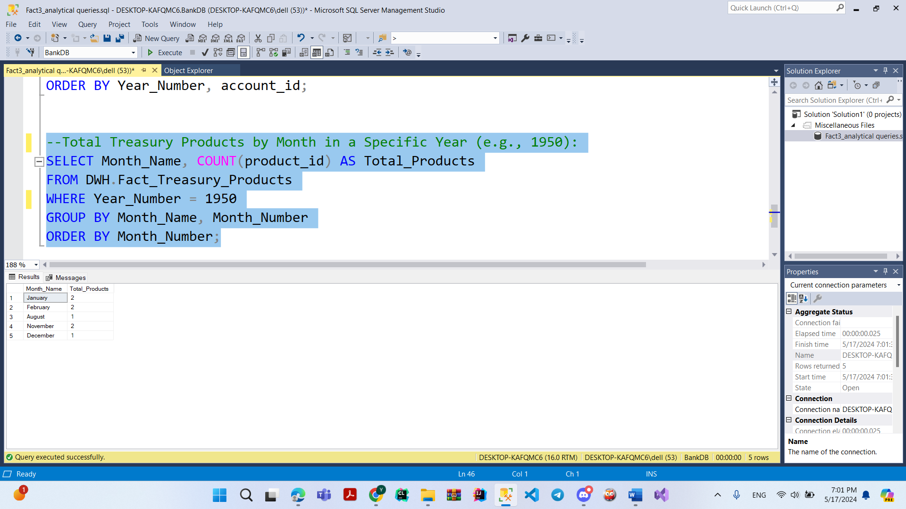

**Queries Screenshot For Payment Fact**

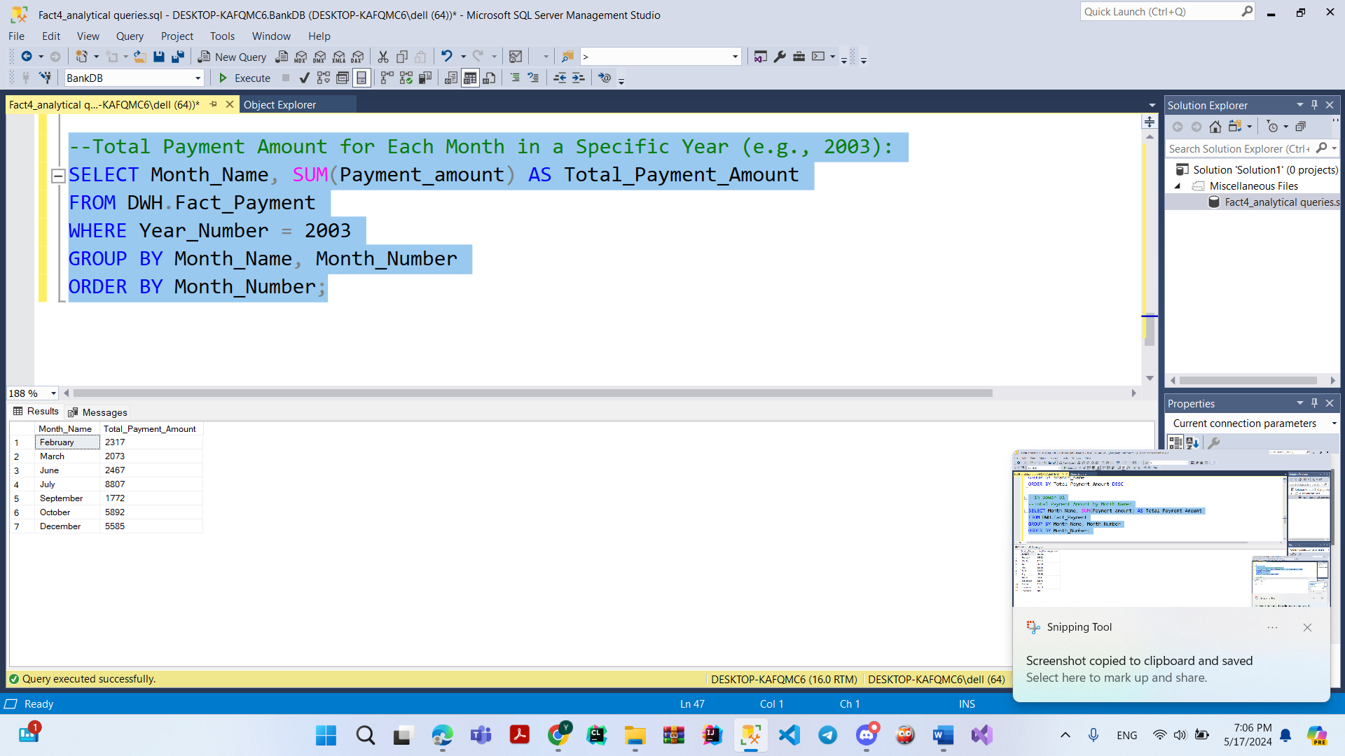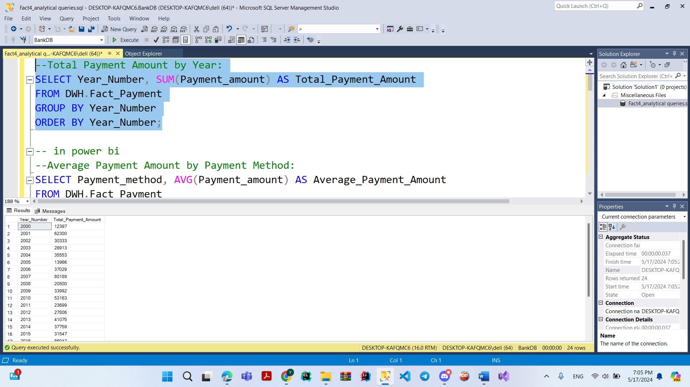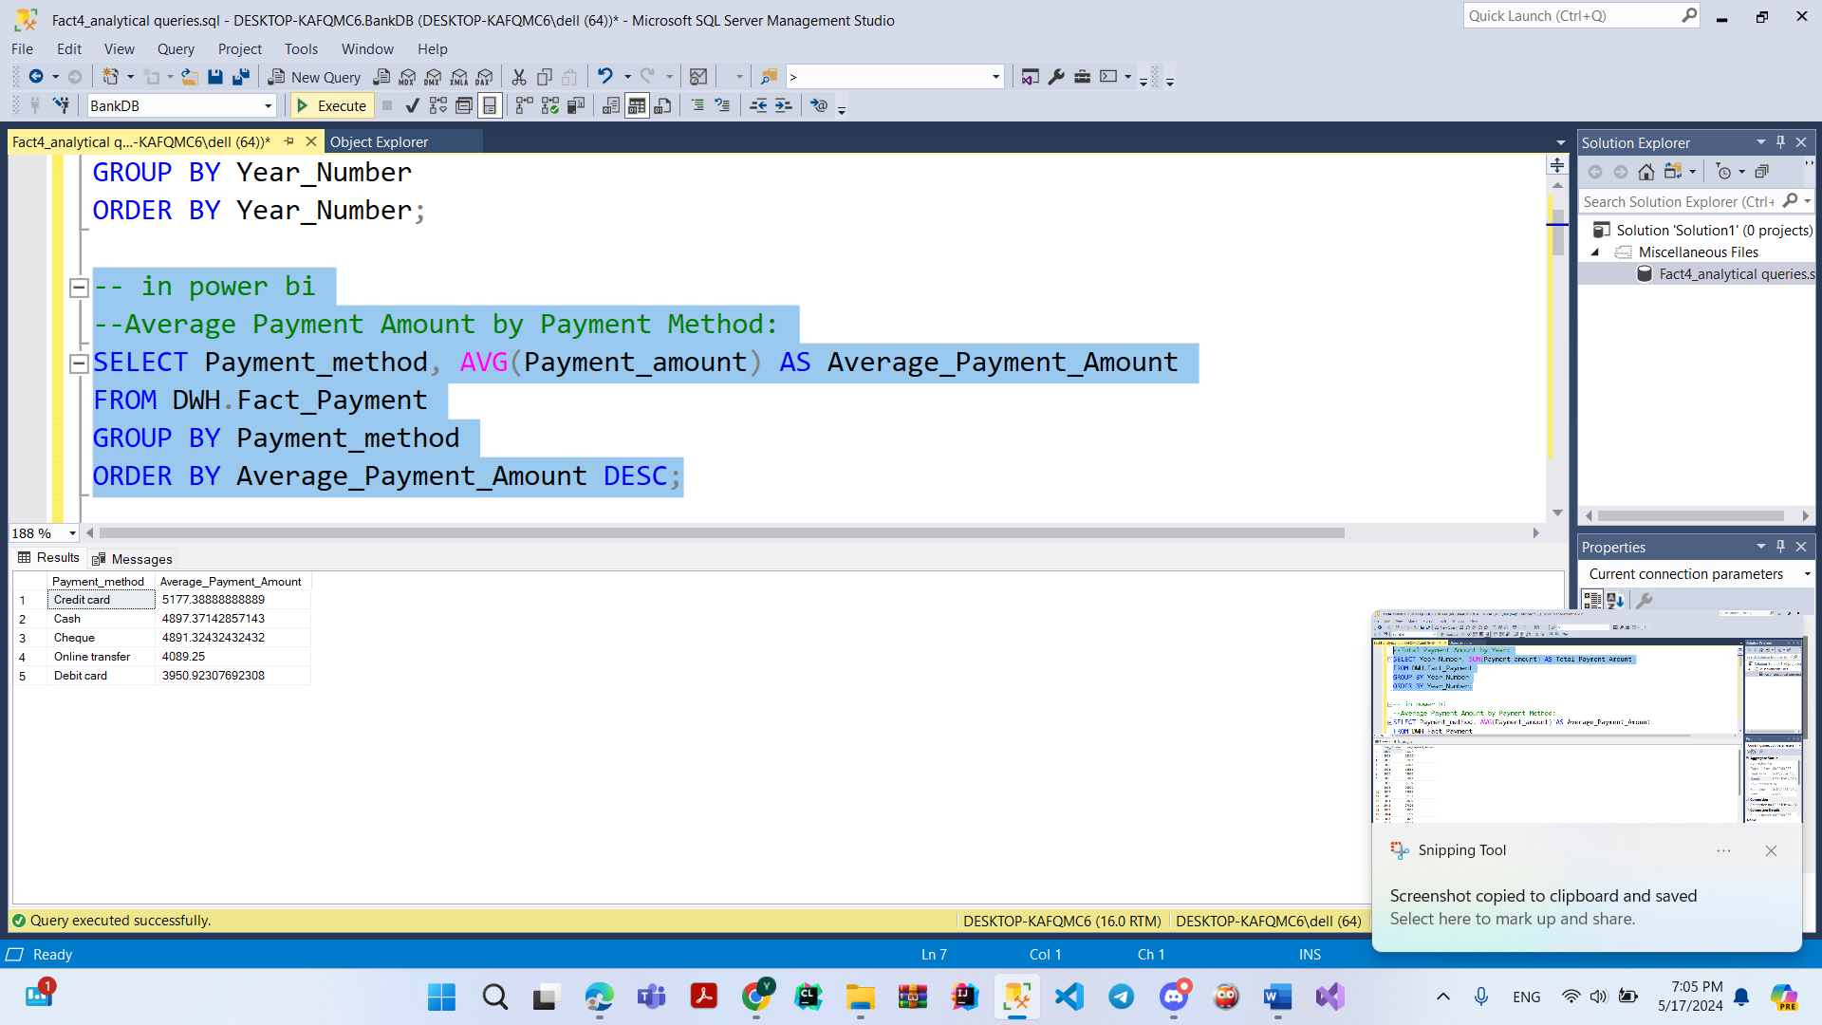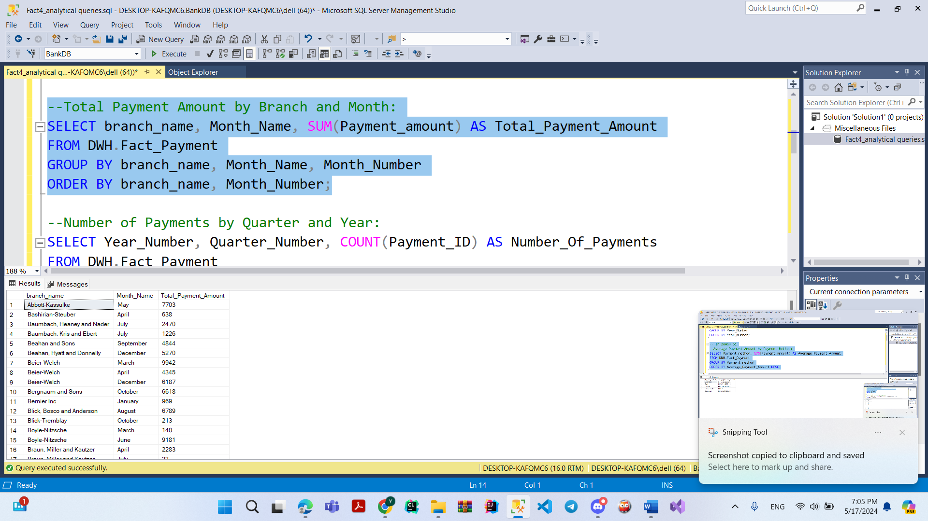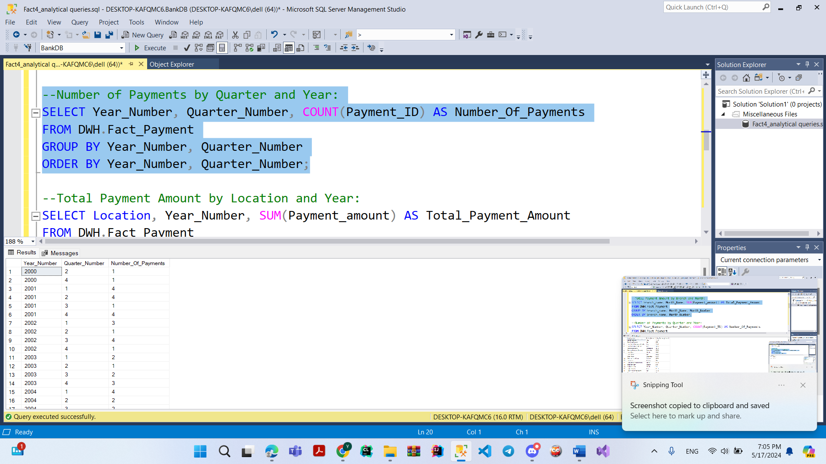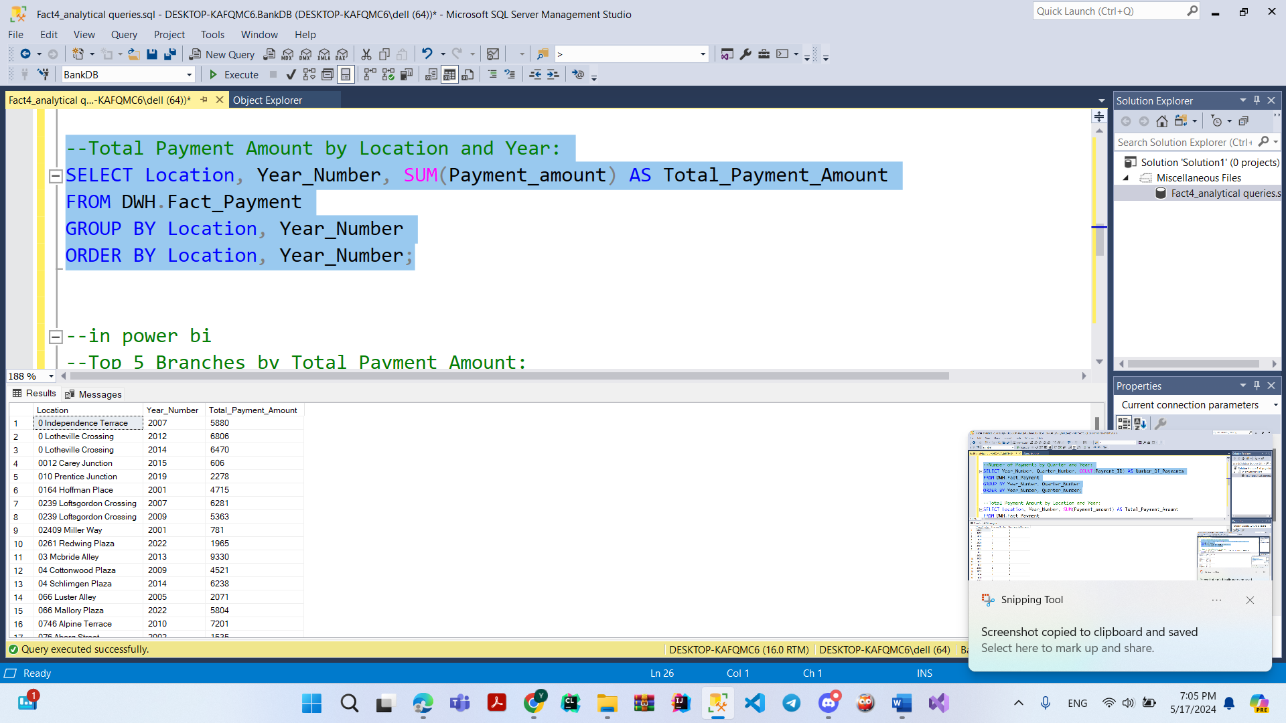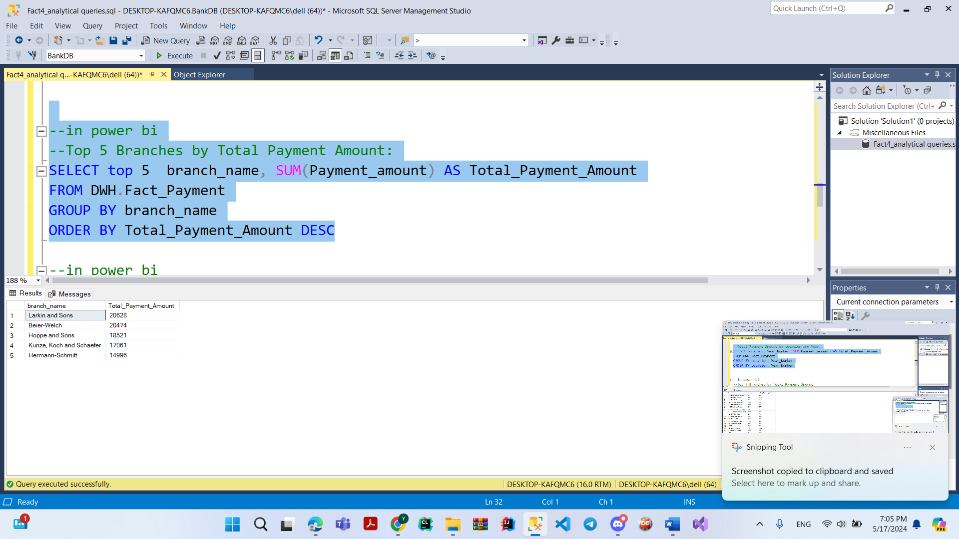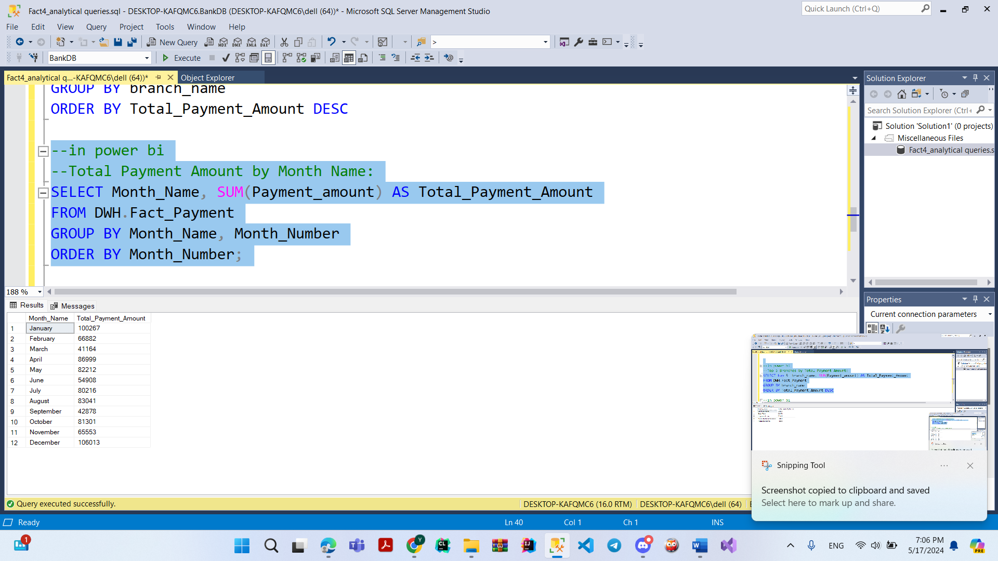

**Deploy Screenshot**

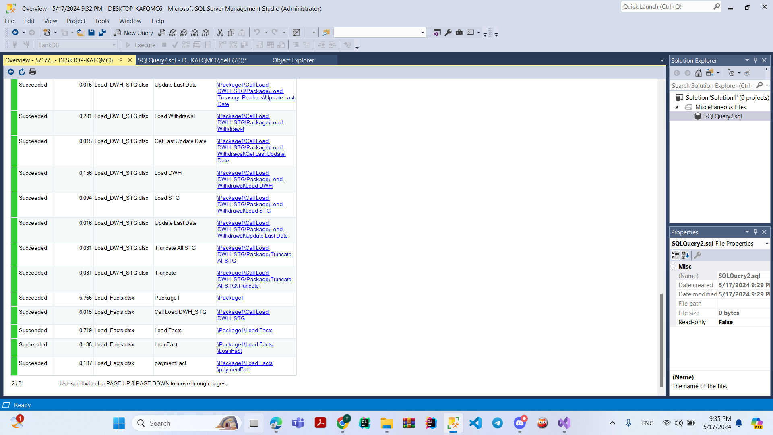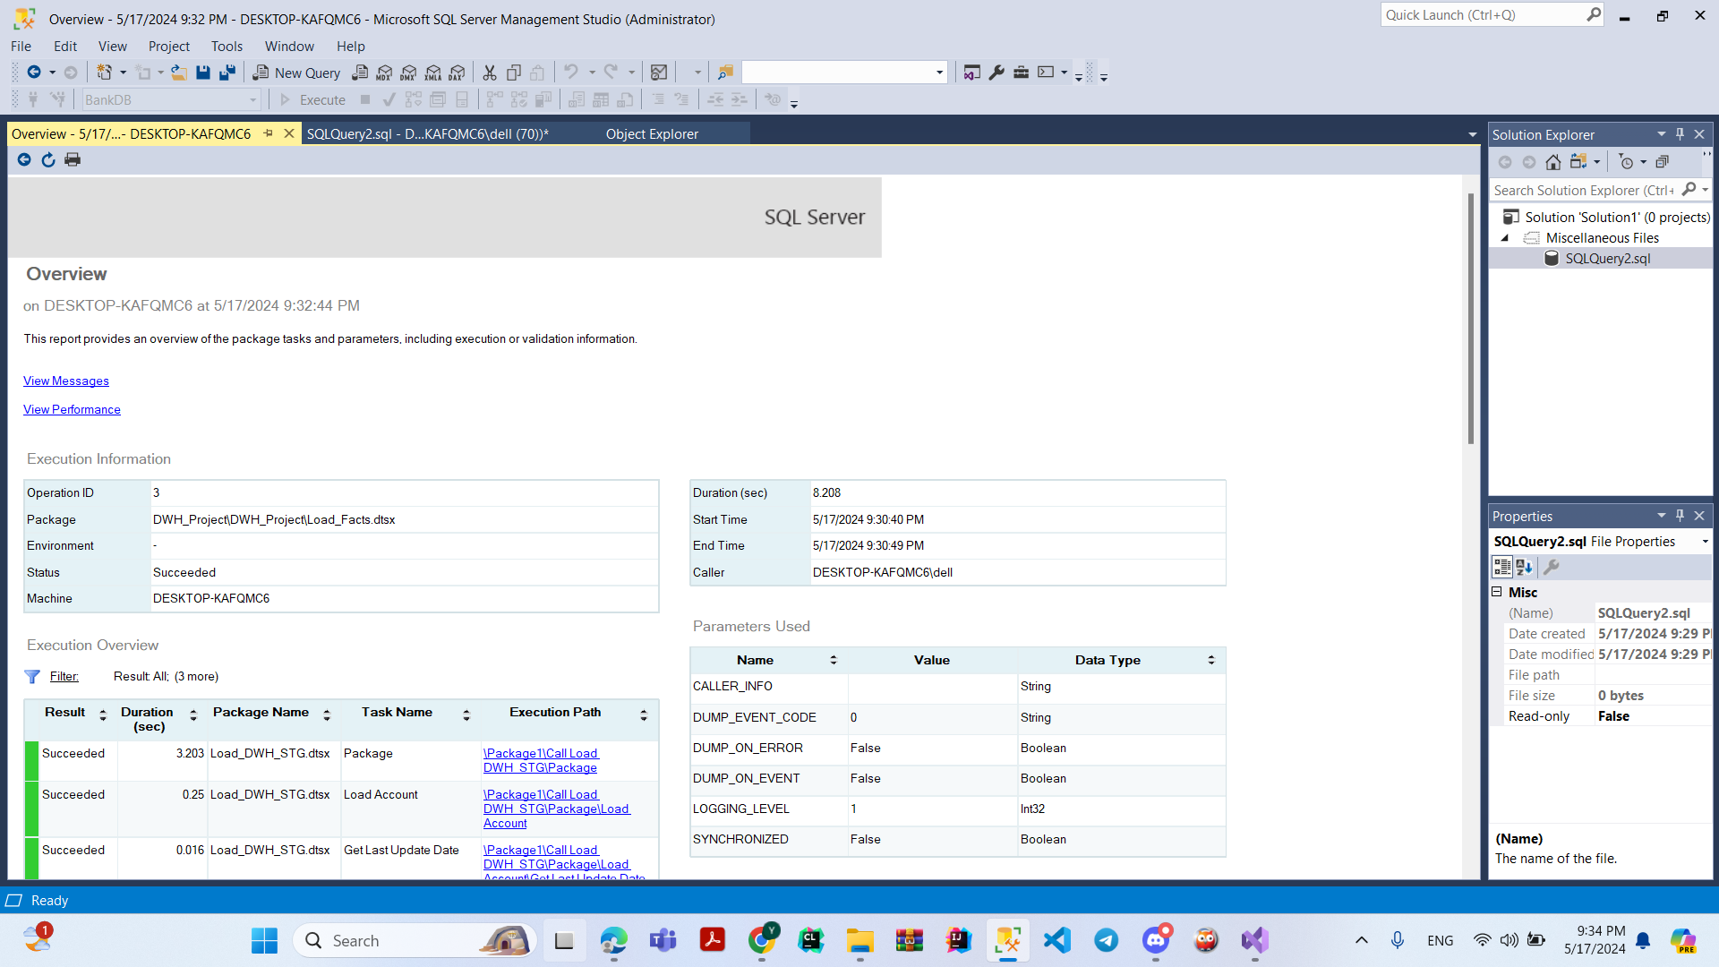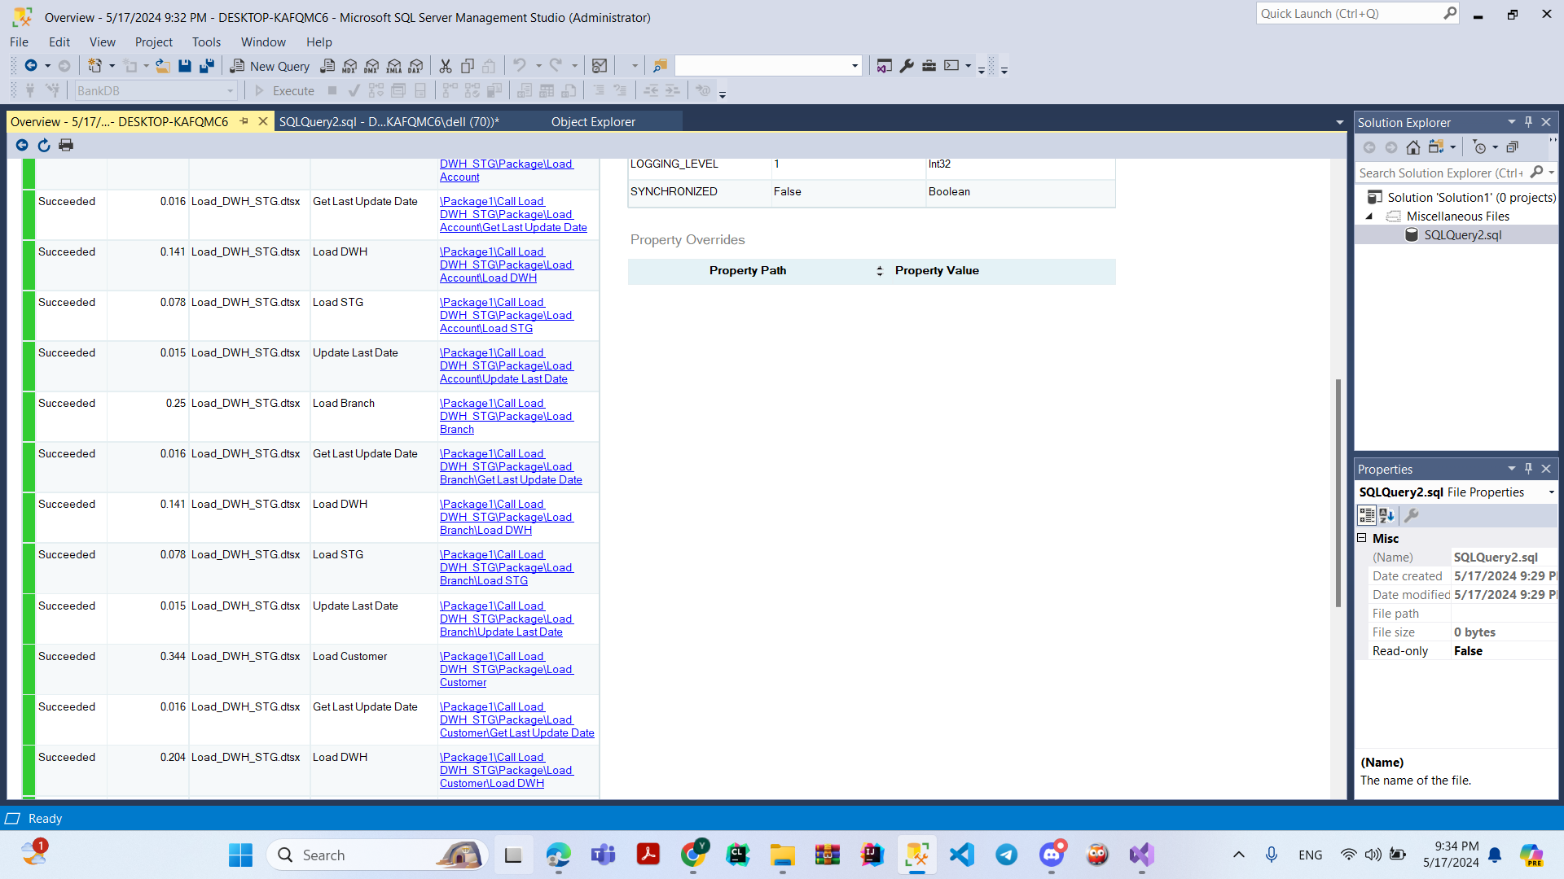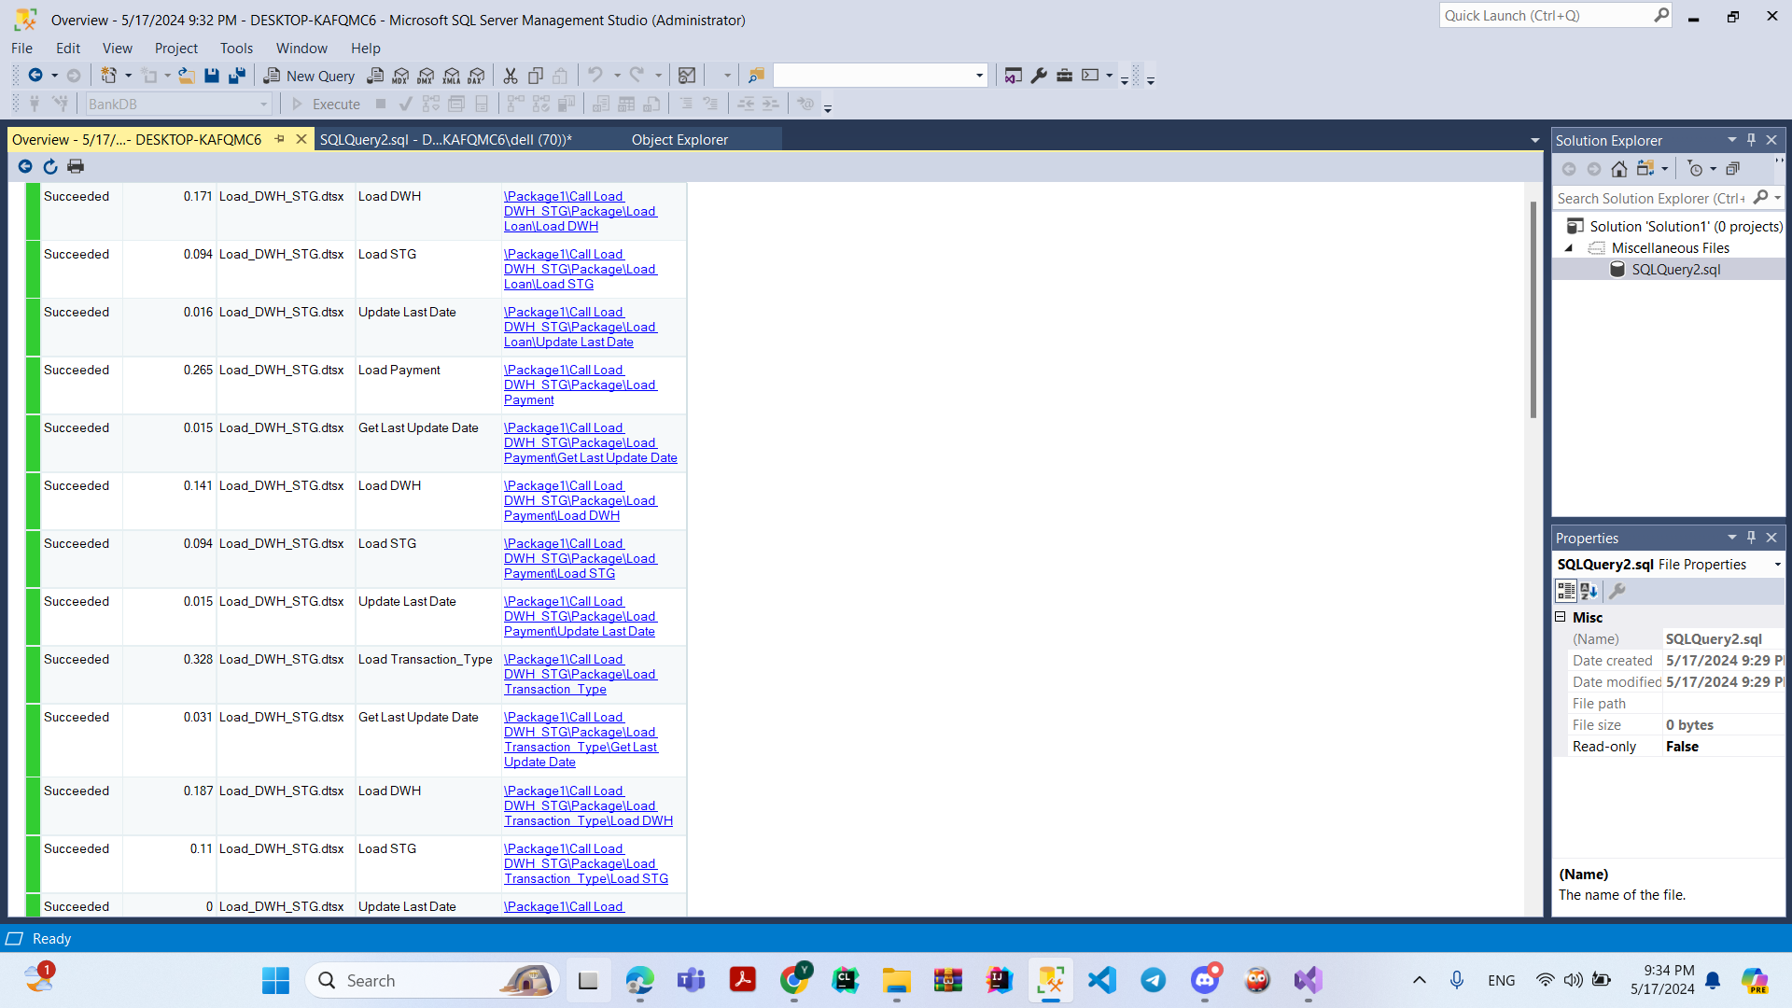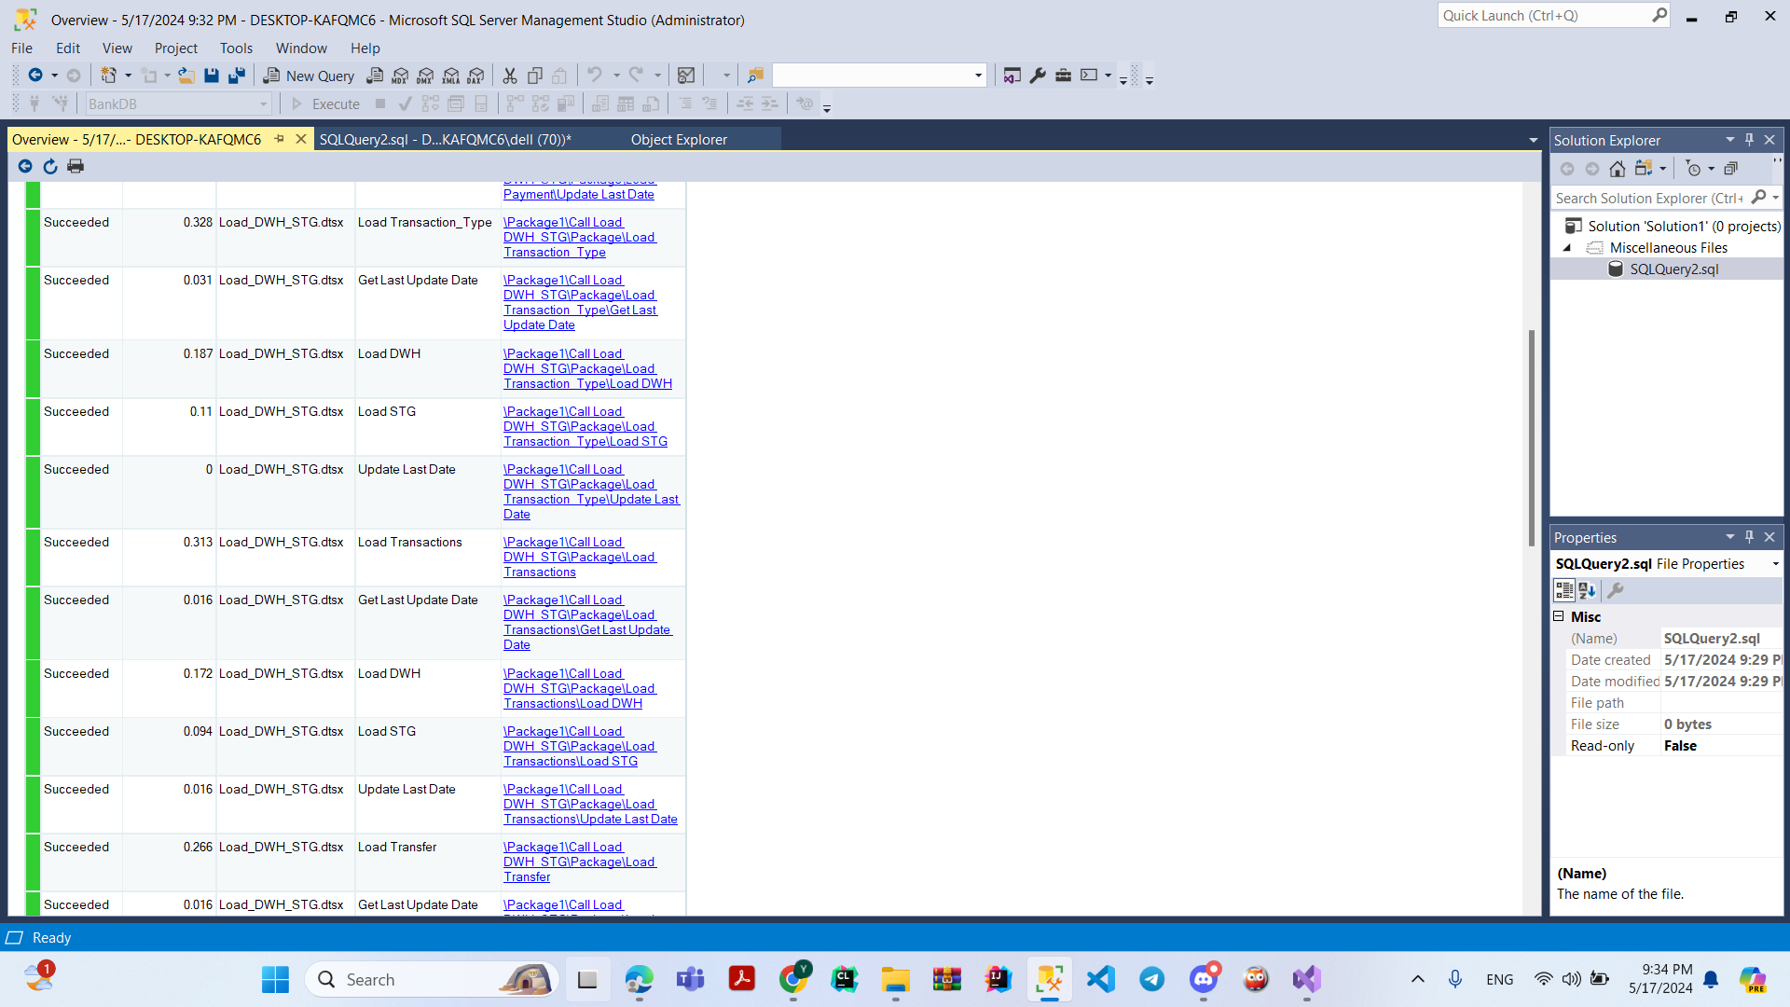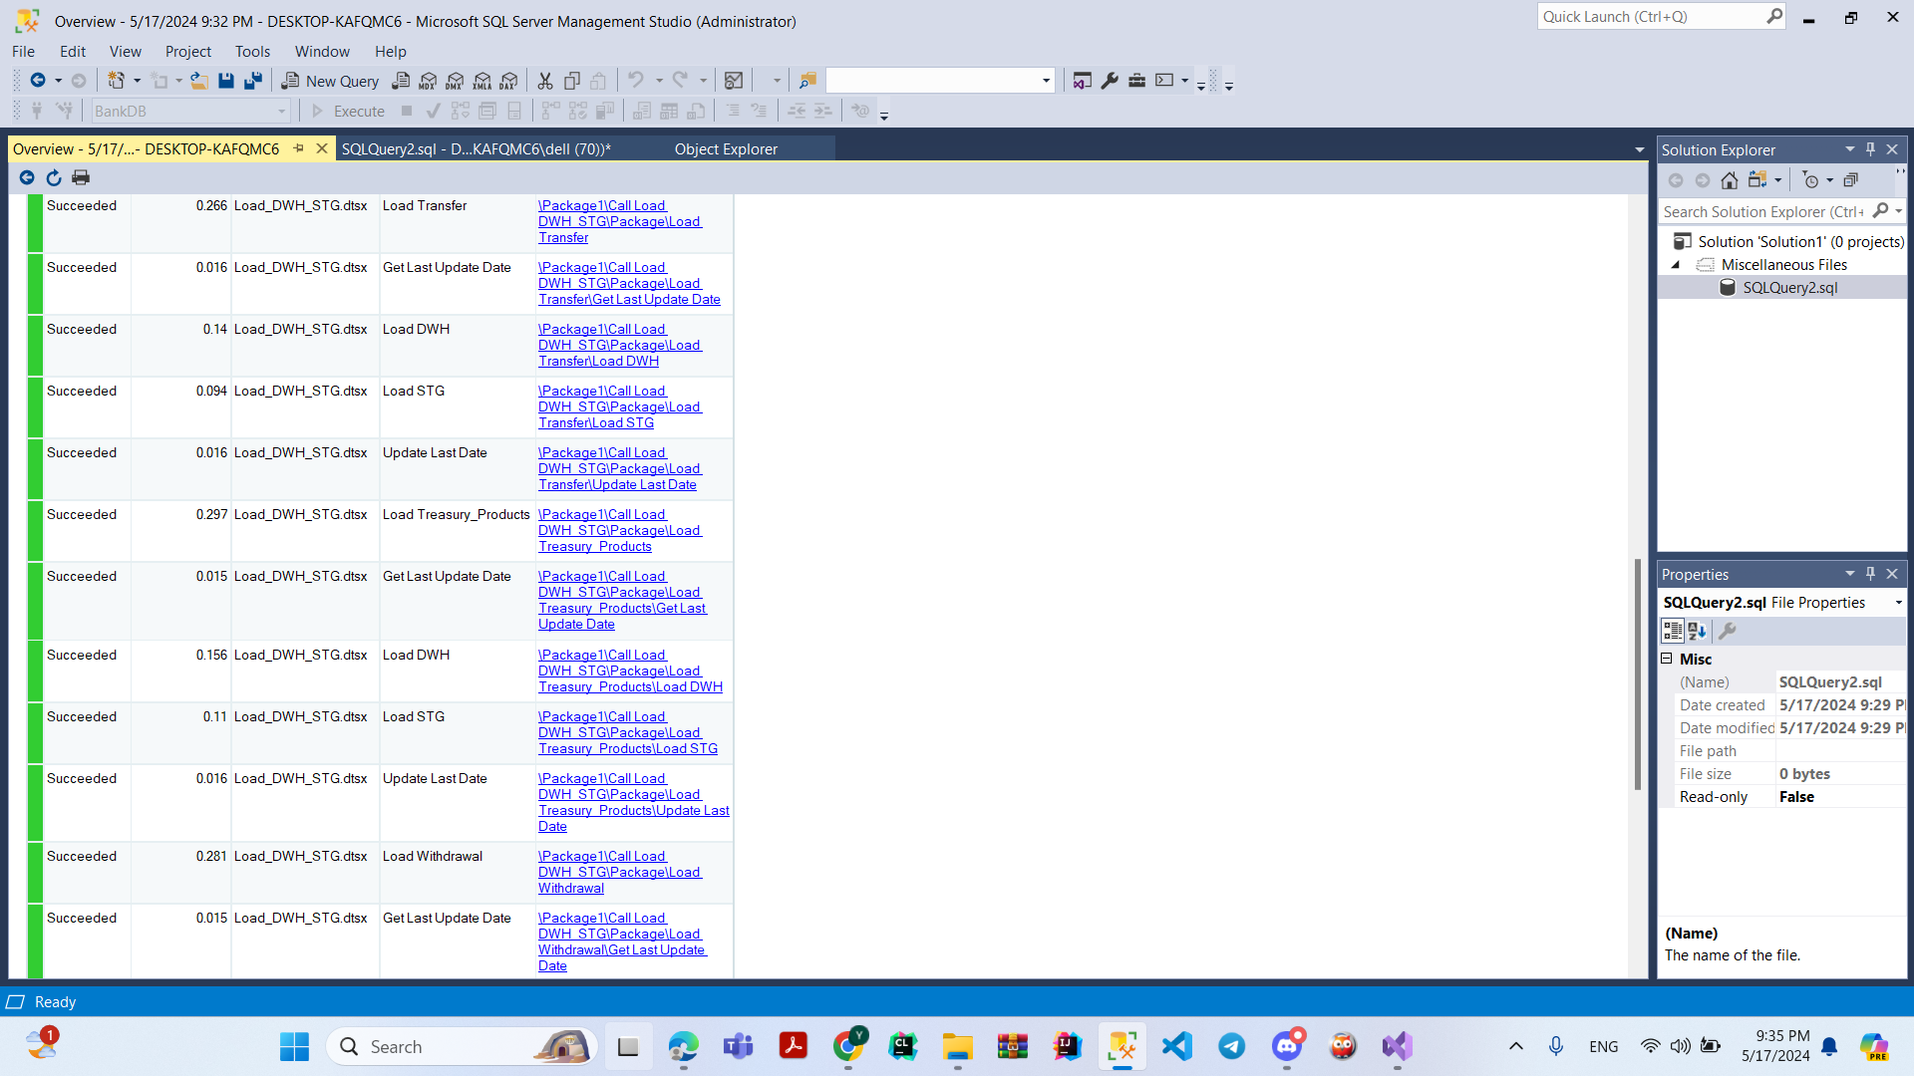

**Schedule Screenshot**

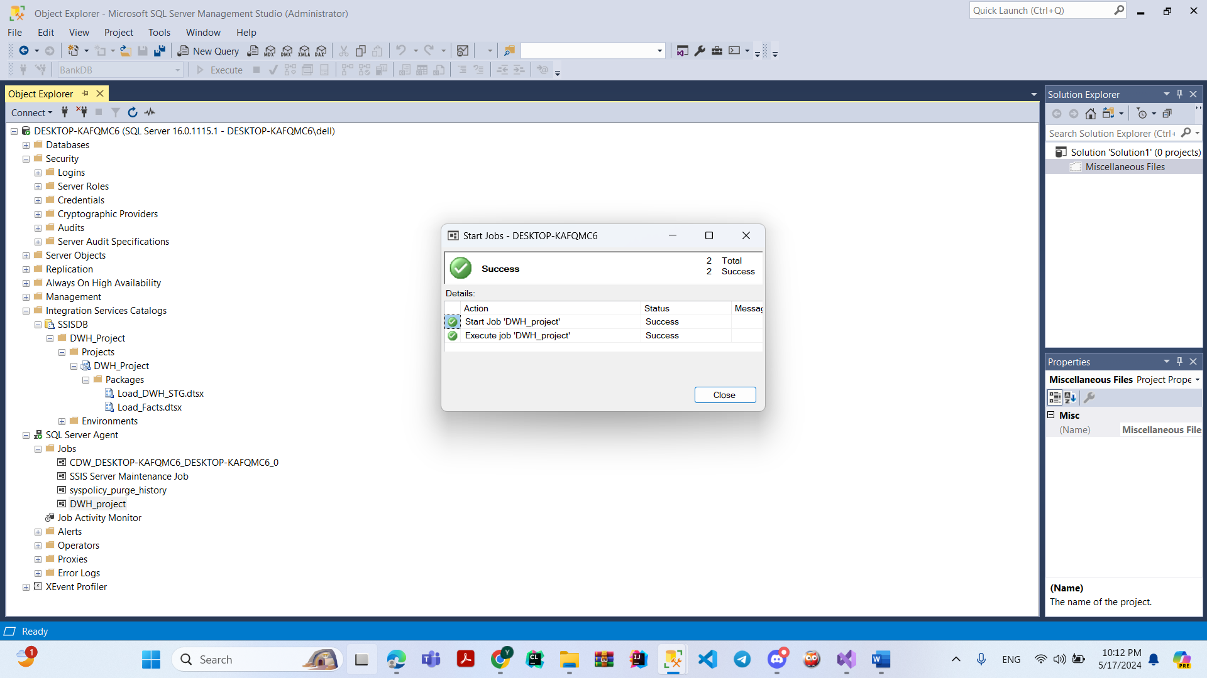

**Dashboard**

